Tour ID: 217620  
Tour Name: 7 Days Self-drive | Golden Circle, South Coast, Snæfellsnes and Reykjavik

Tour destinations: ['Keflavik', 'Blue Lagoon', 'Borgarnes', 'Arnarstapi', 'Kirkjufell Mountain', 'Reykholt', 'Thingvellir National Park', 'Geysir', 'Gullfoss', 'Kerid Volcano', 'Skogafoss', 'Reynisfjara', 'Kirkjubaejarklaustur', 'Jokulsarlon', 'Hvolsvollur', 'Reykjavik']

Tour destinations images:

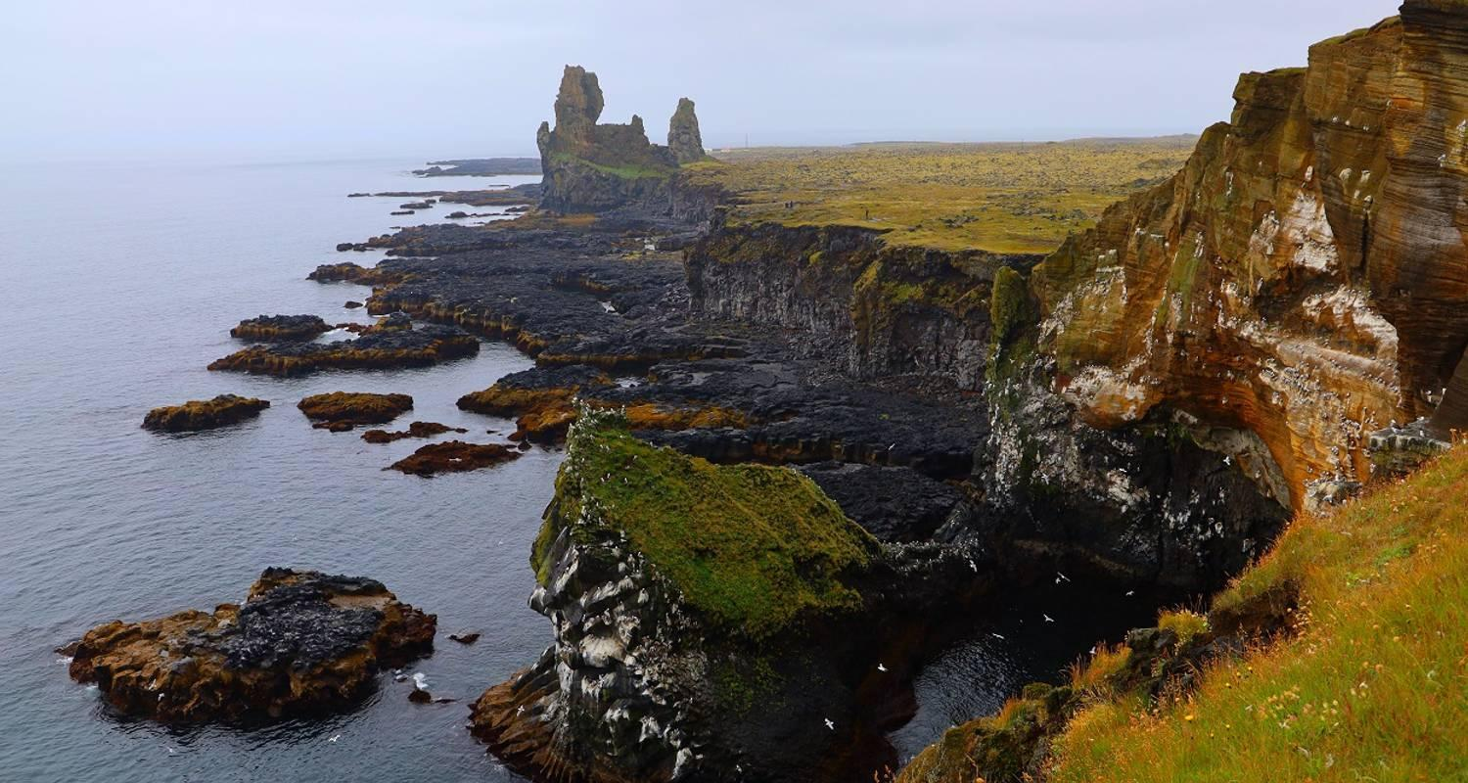

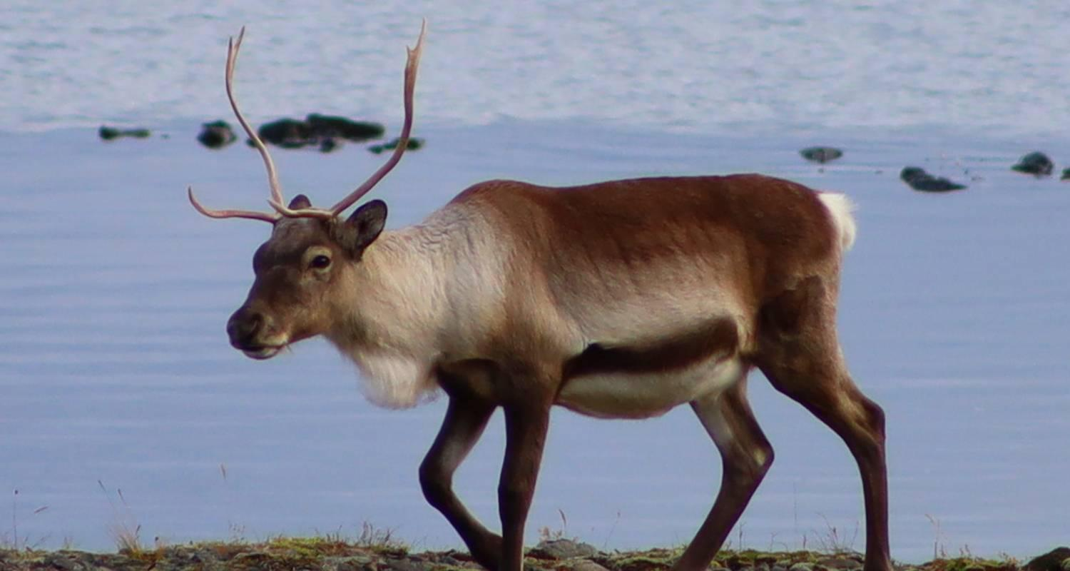

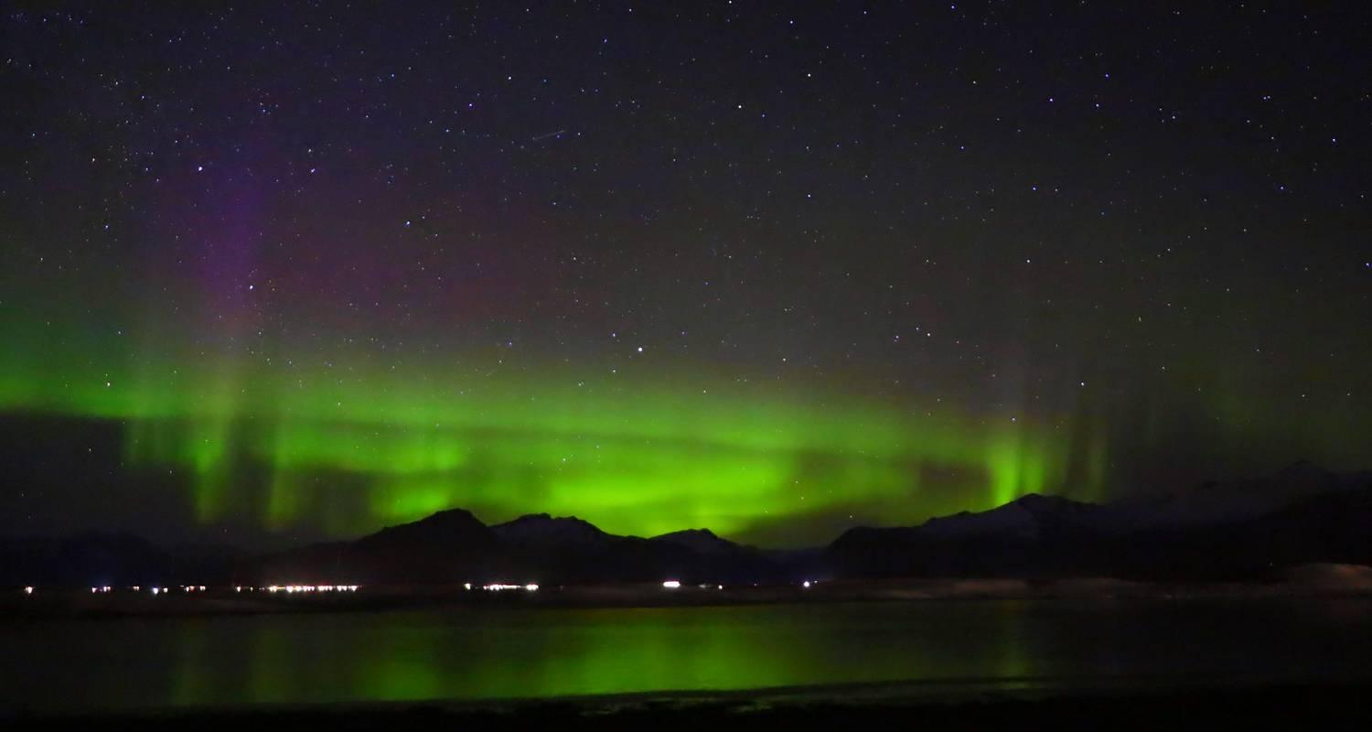

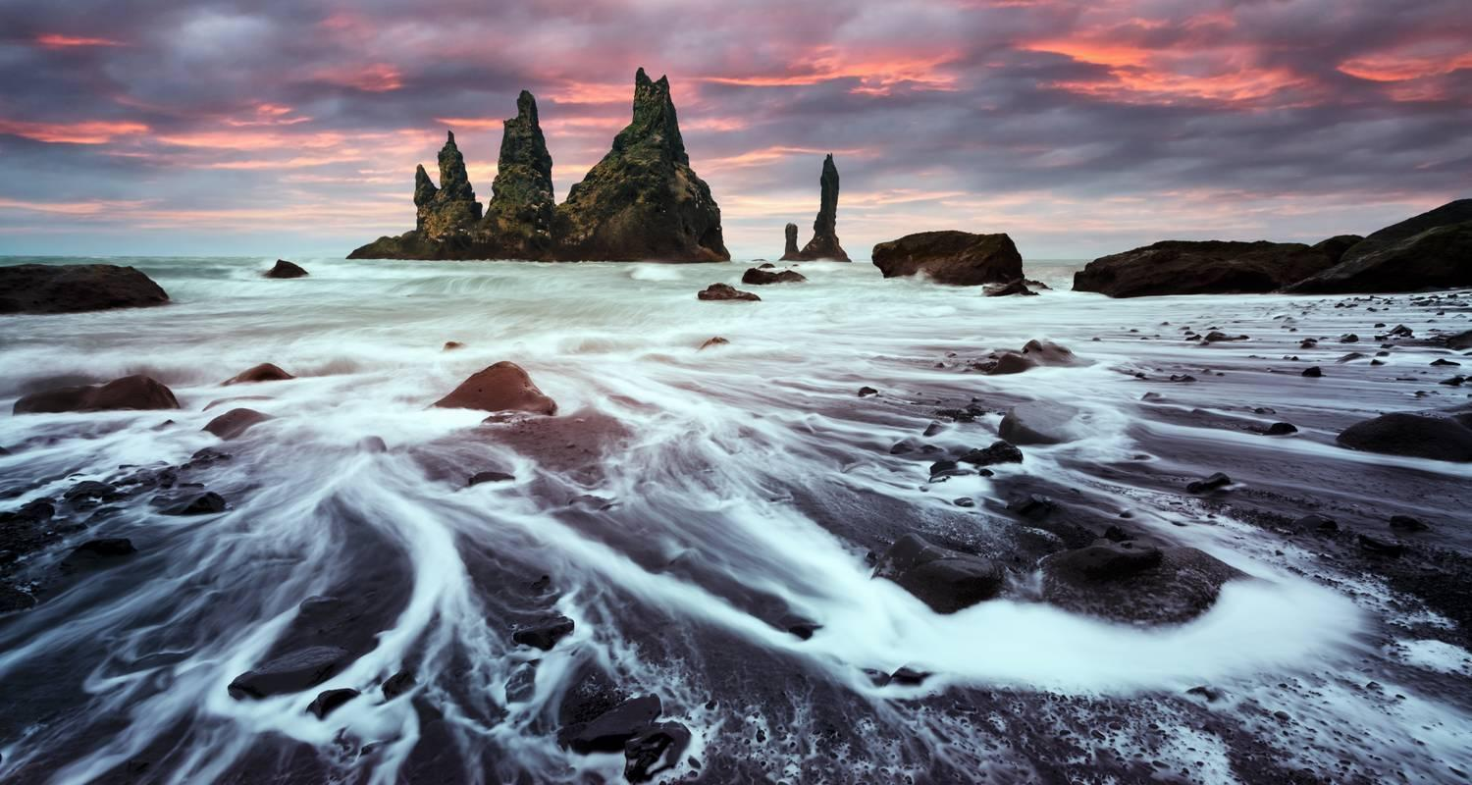

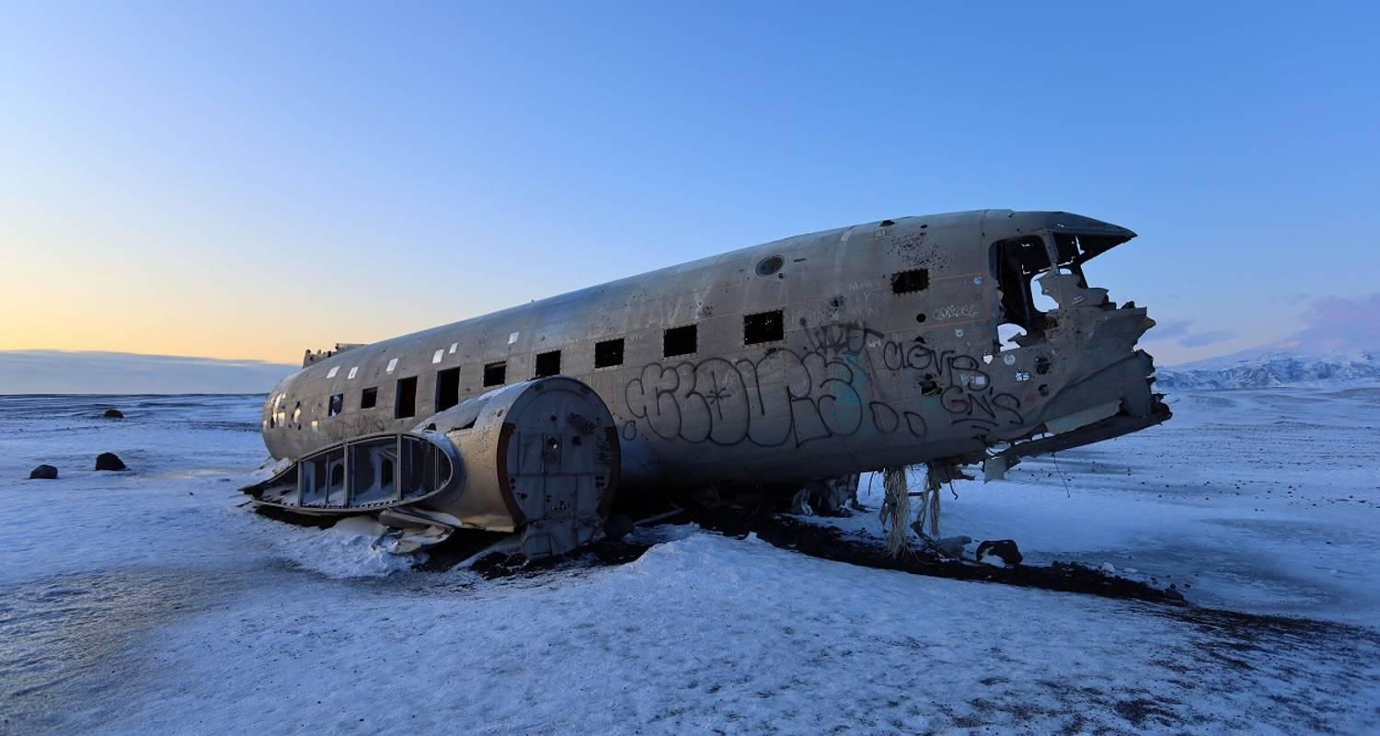

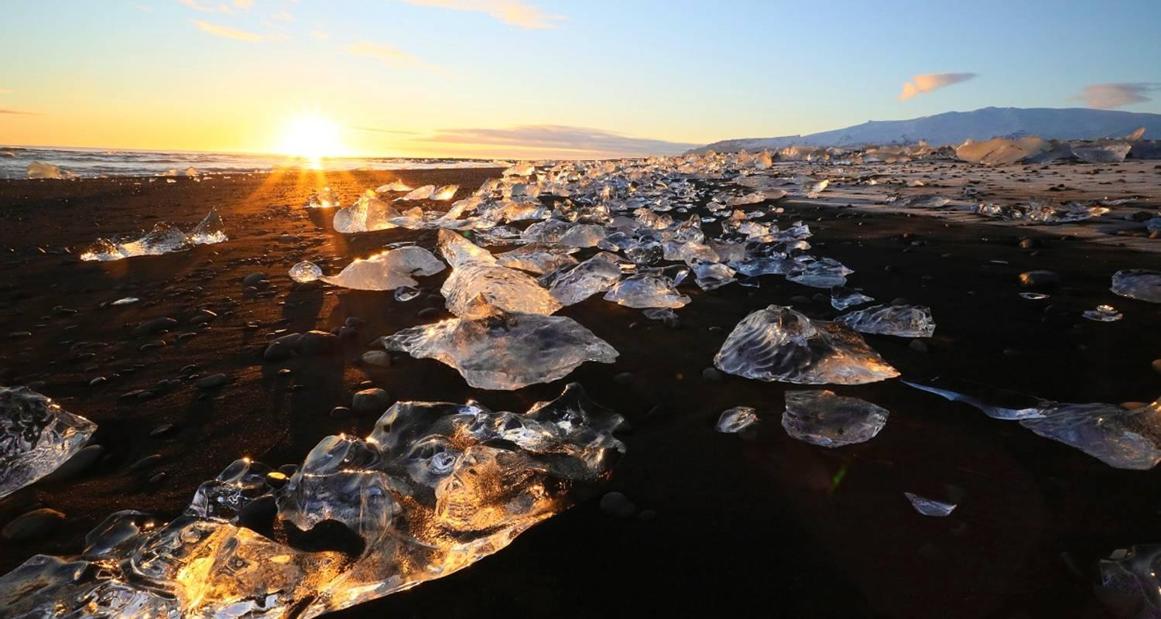

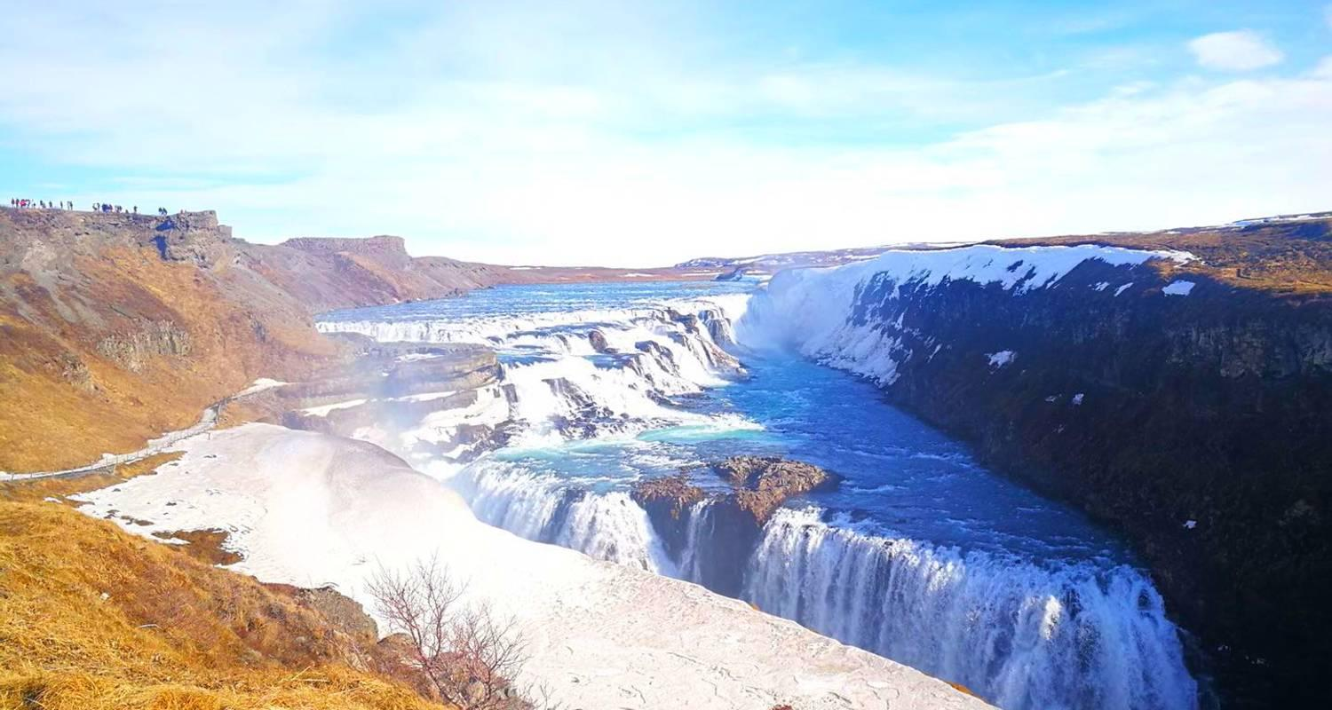

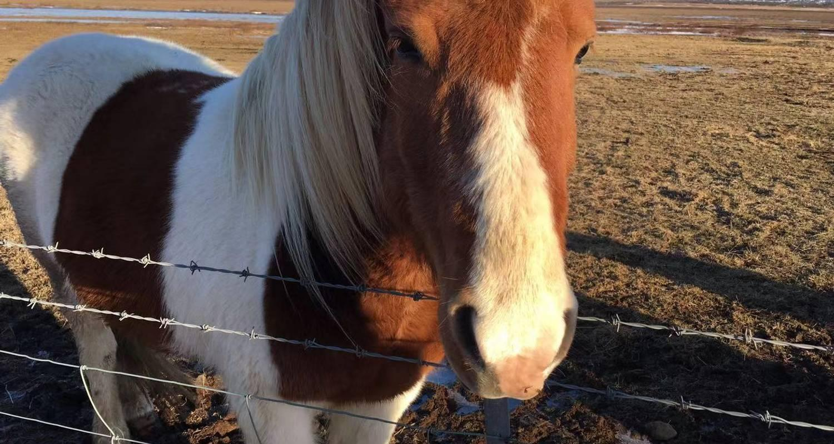

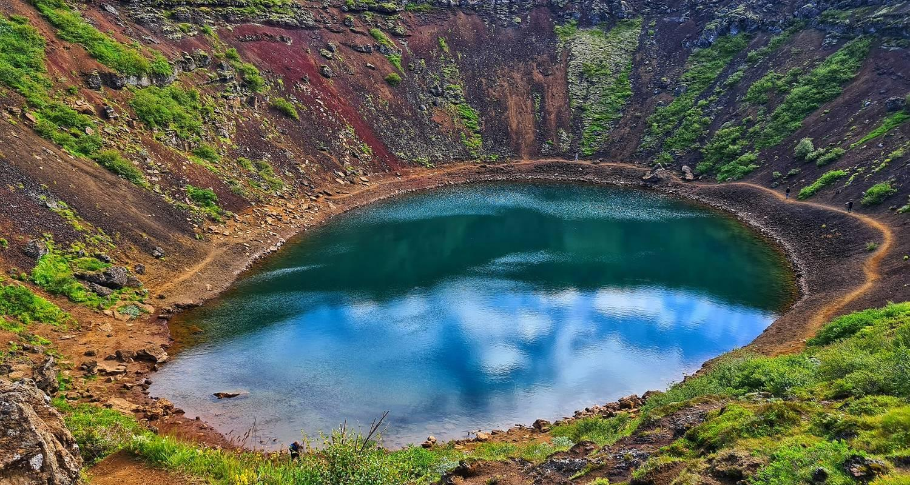

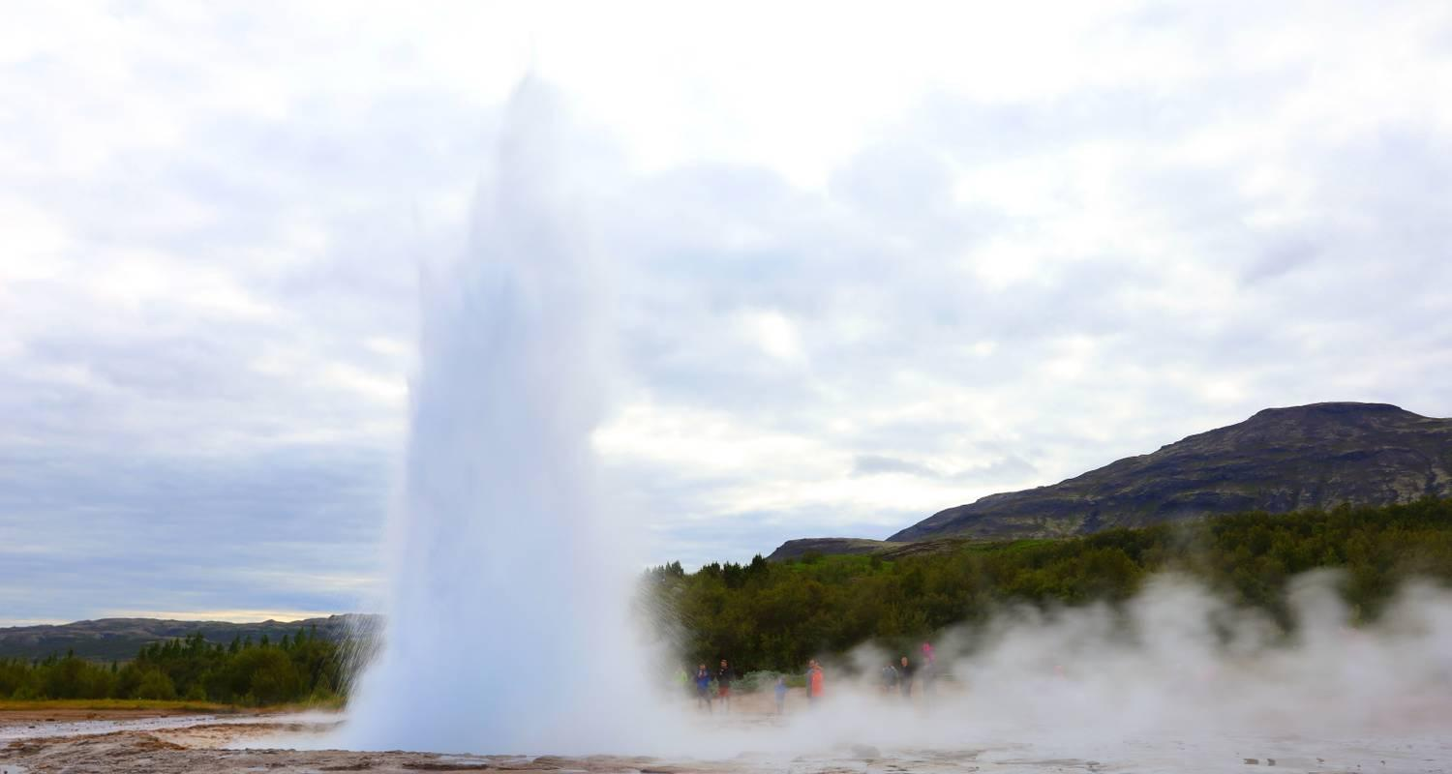

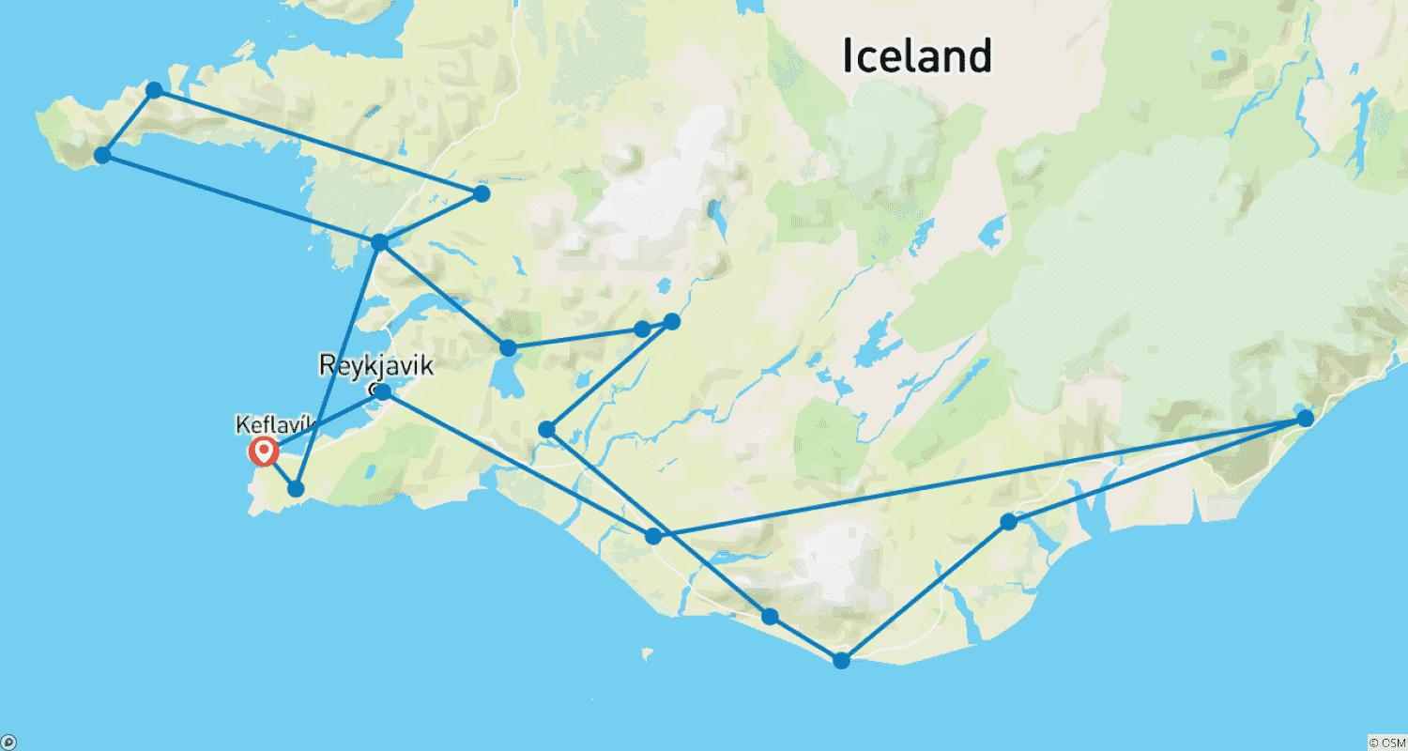

Tour ID: 218263  
Tour Name: Iceland's Golden Circle in Depth

Tour destinations: ['Reykjavik', 'Hvolsvollur', 'Geysir', 'Gullfoss', 'Seljaland', 'Skogafoss', 'Solheimajokull', 'Thingvellir National Park']

Tour destinations images:

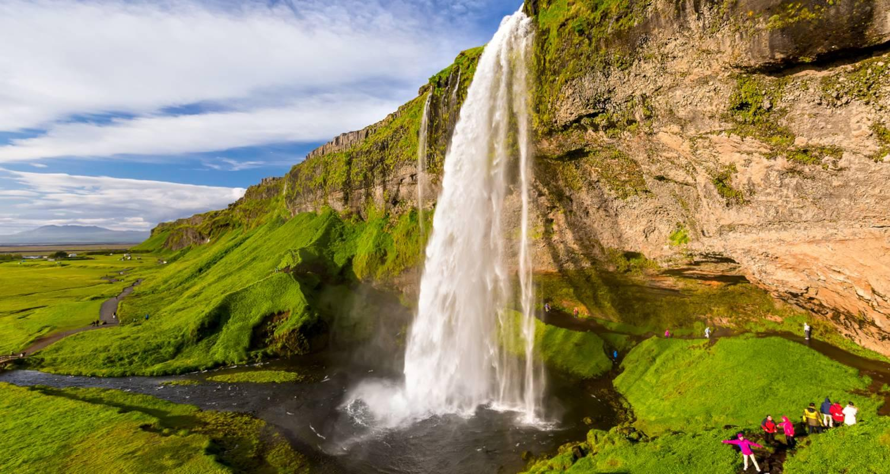

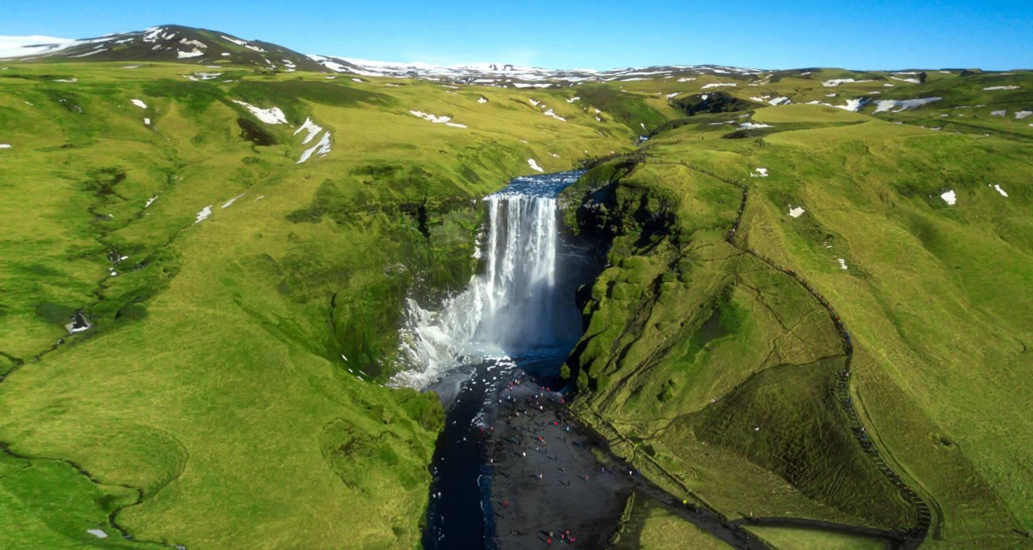

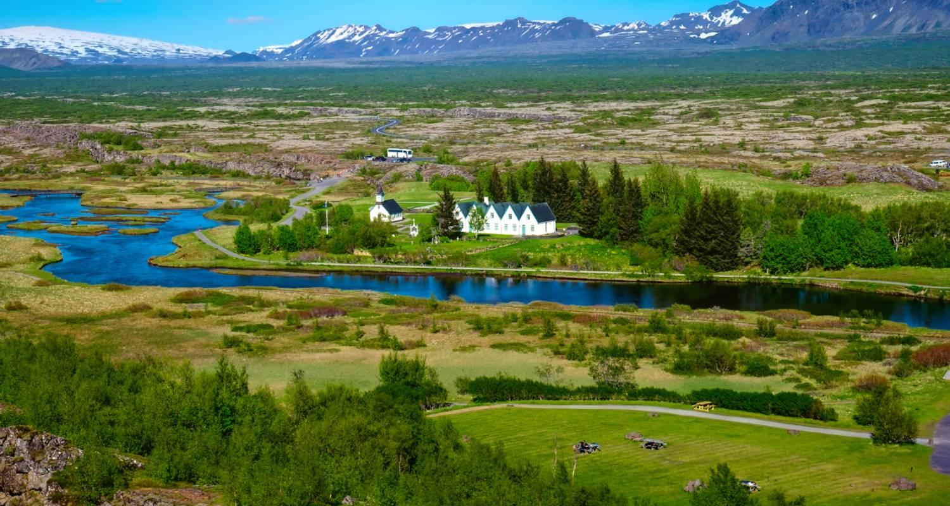

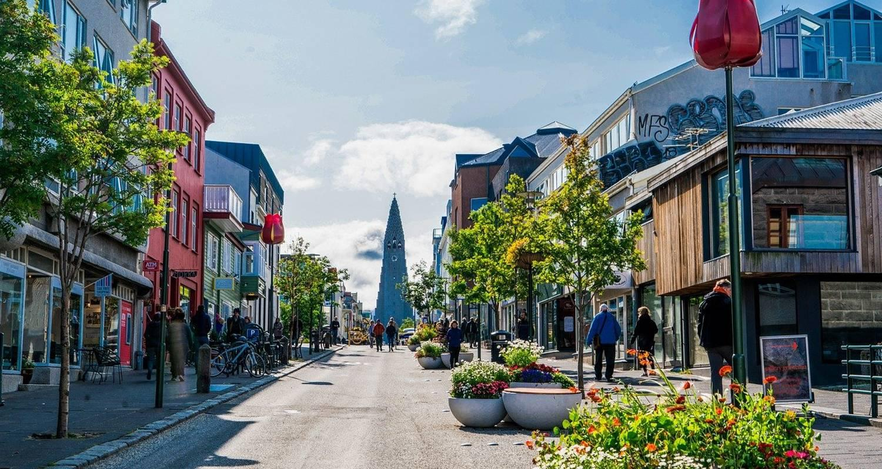

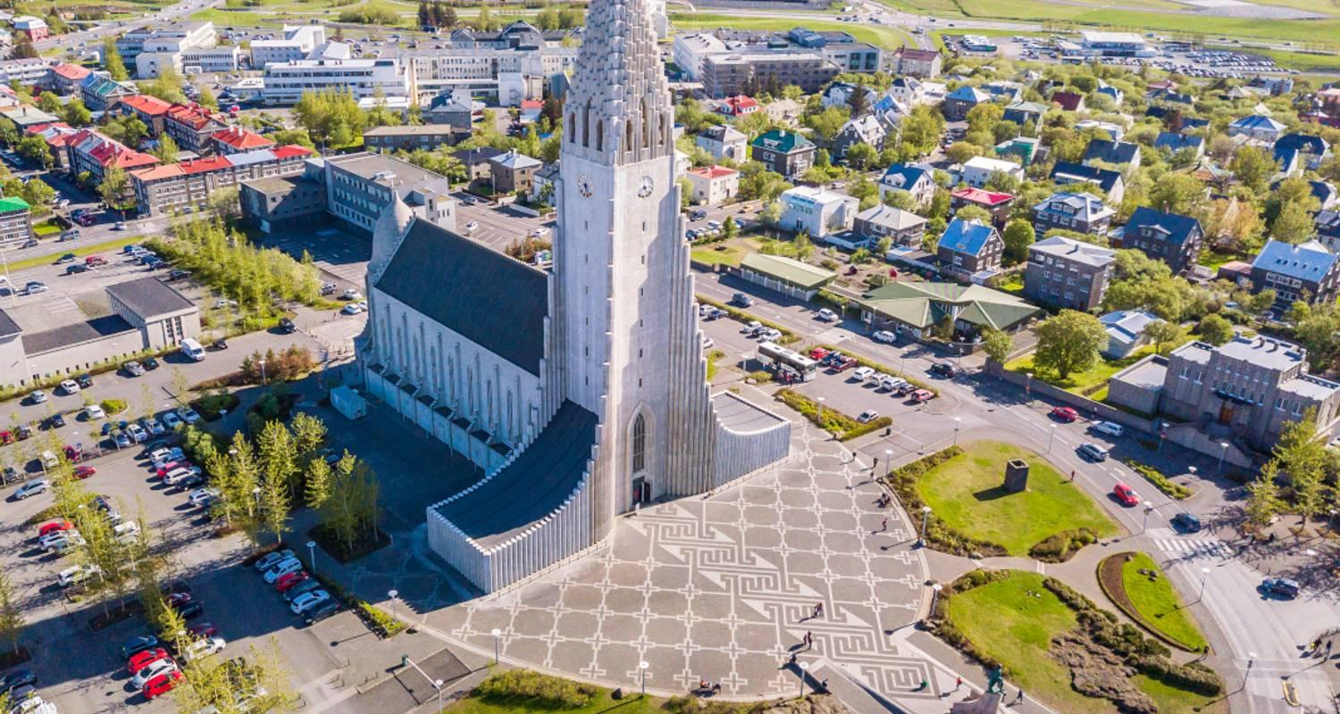

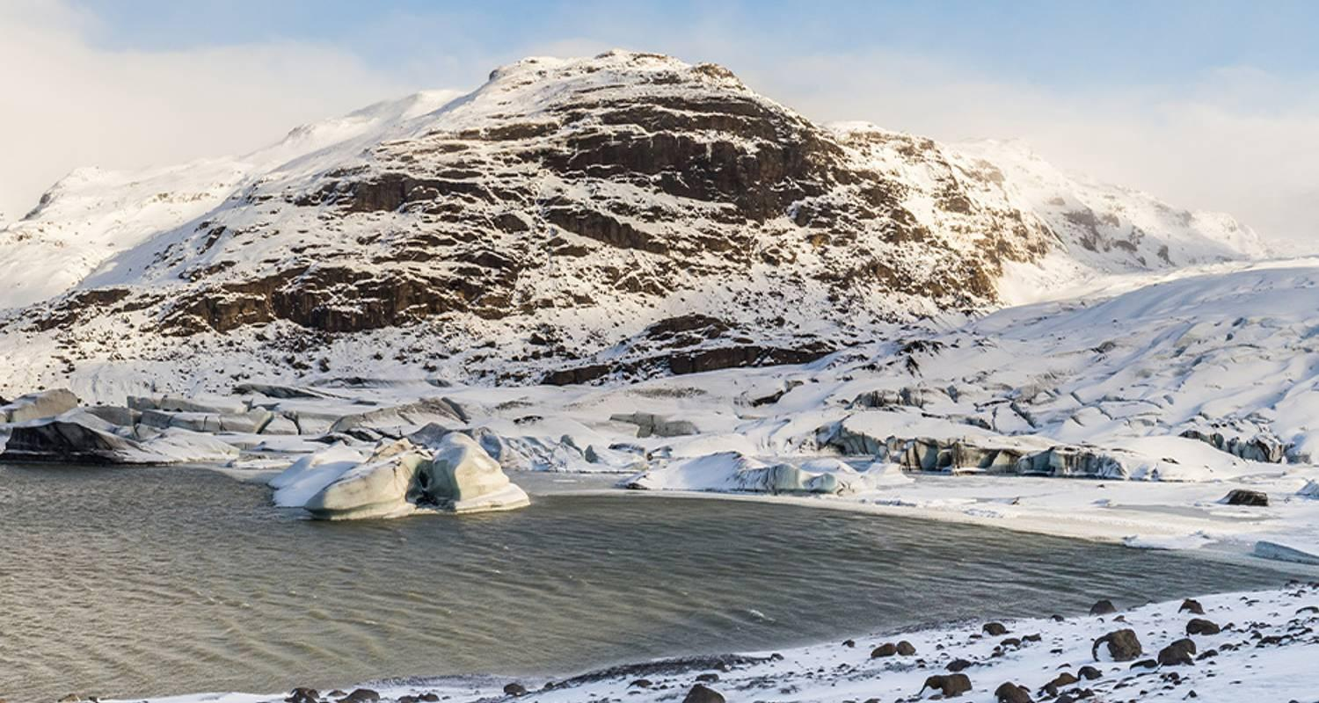

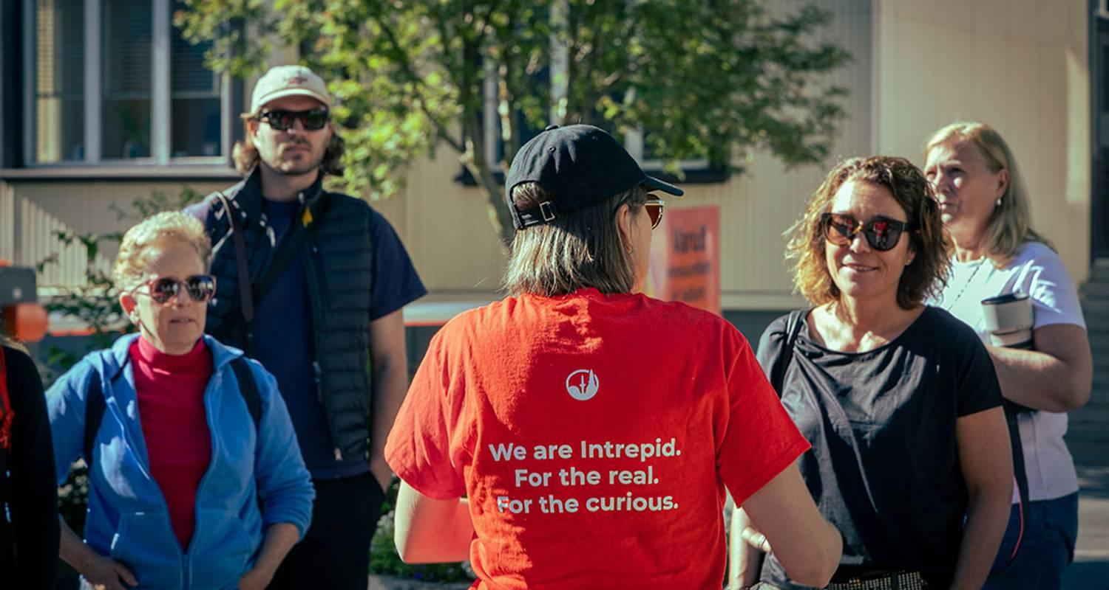

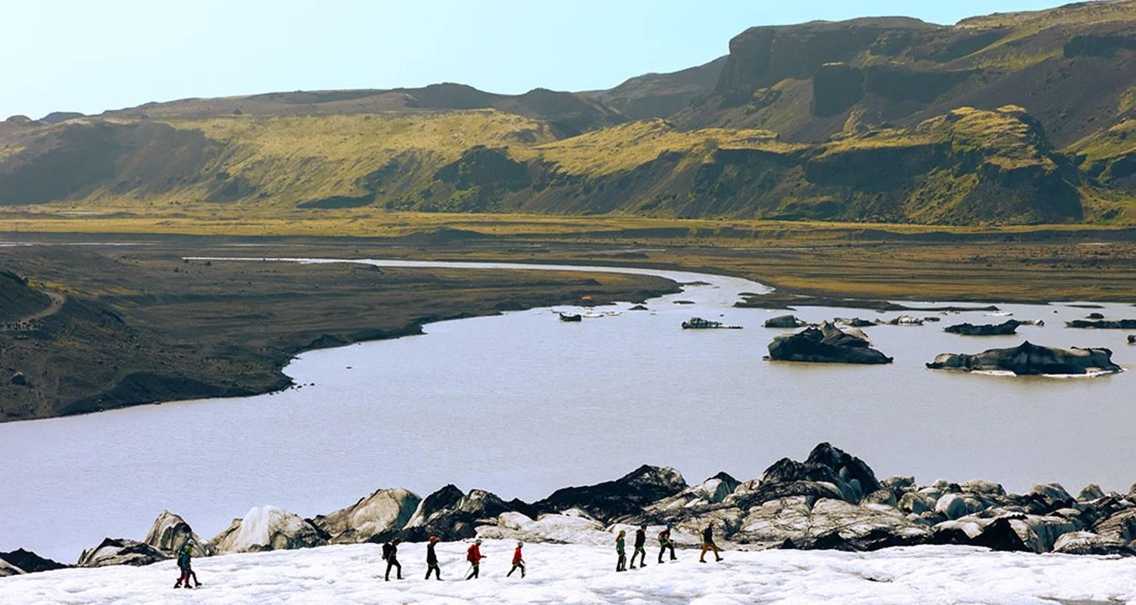

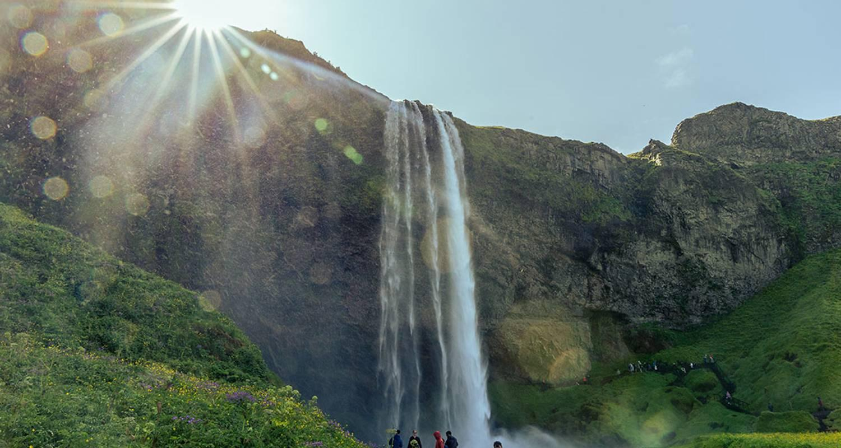

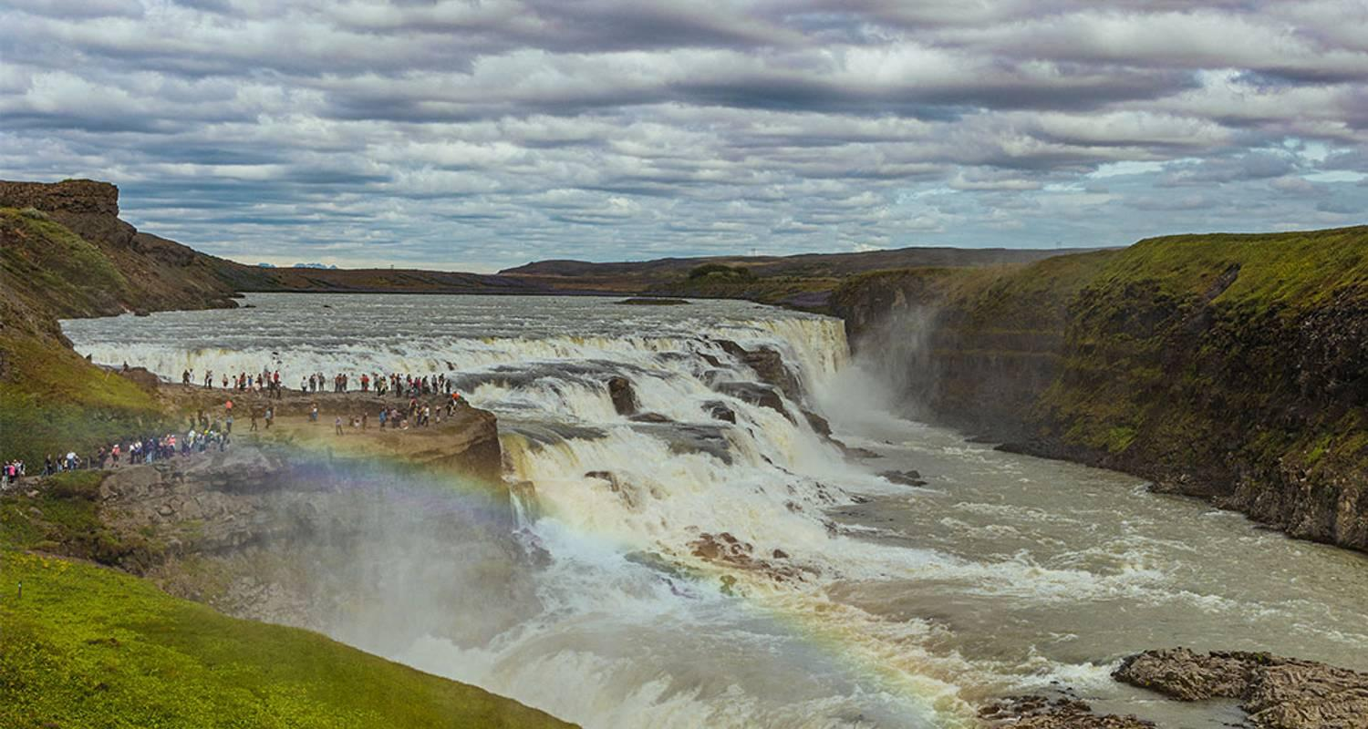

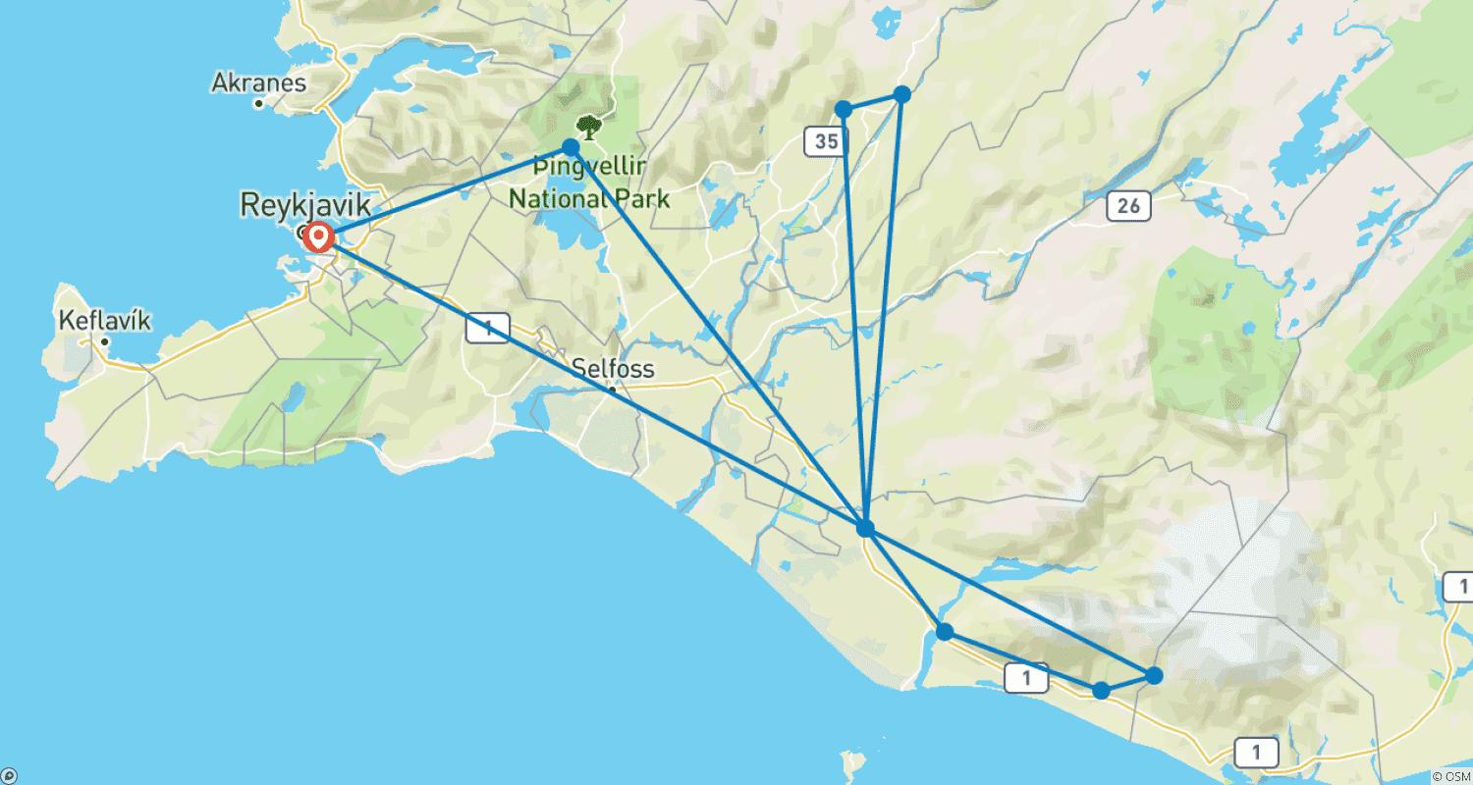

Tour ID: 218492  
Tour Name: Greenland Disko Bay Discovered - 8 Days

Tour destinations: ['Reykjavik', 'Kangerlussuaq', 'Sisimiut', 'Qeqertarsuaq', 'Ilulissat', 'Sarfannguit', 'Itilleq']

Tour destinations images:

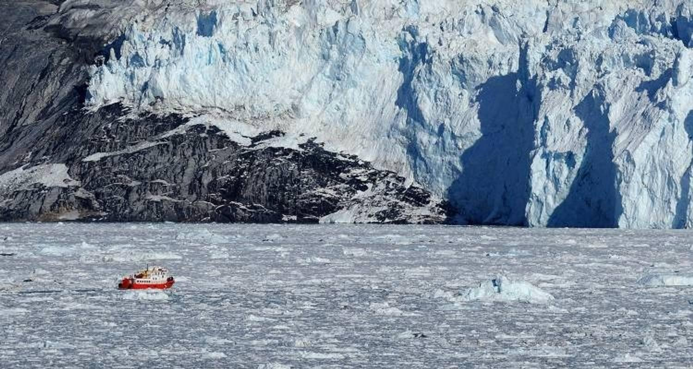

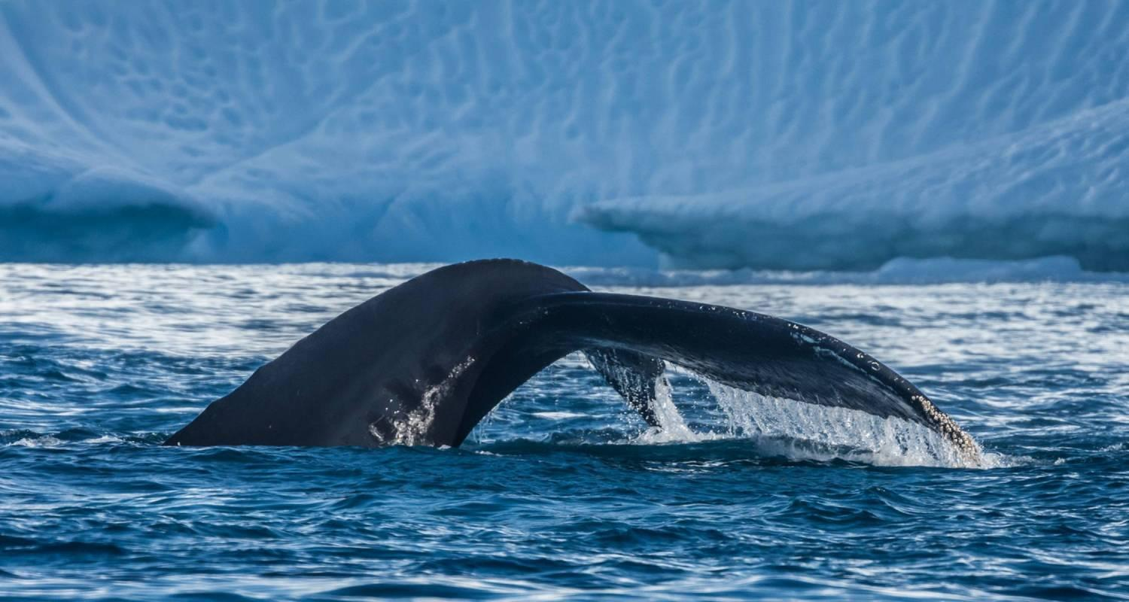

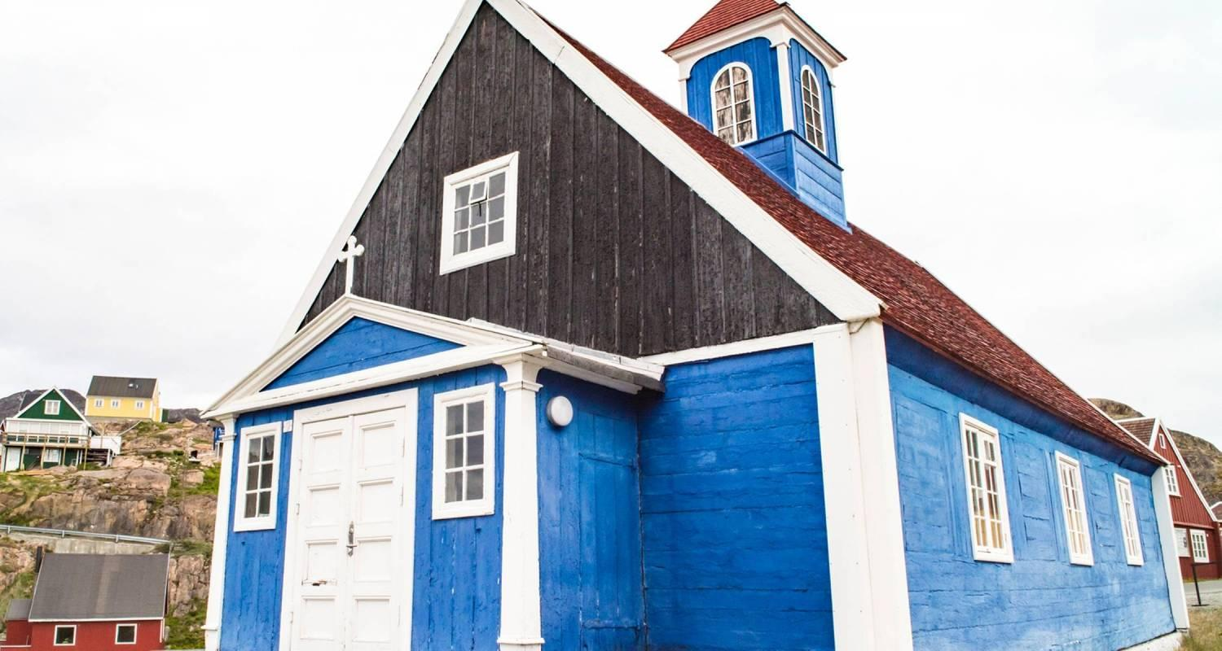

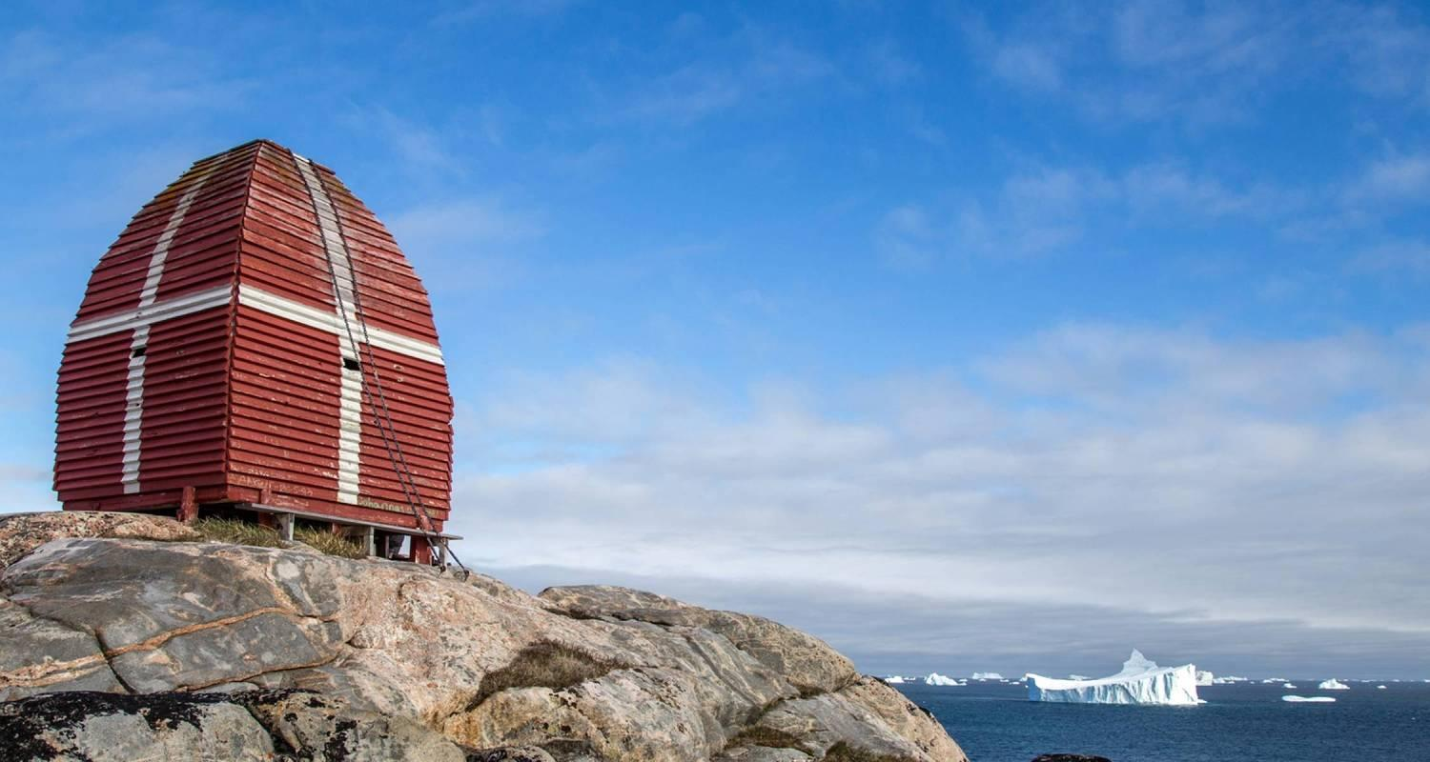

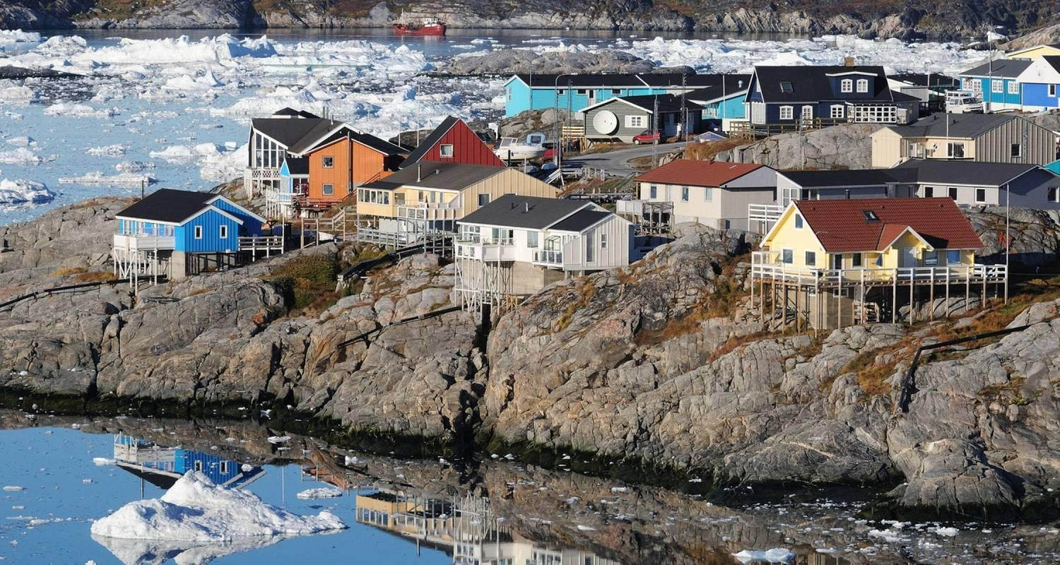

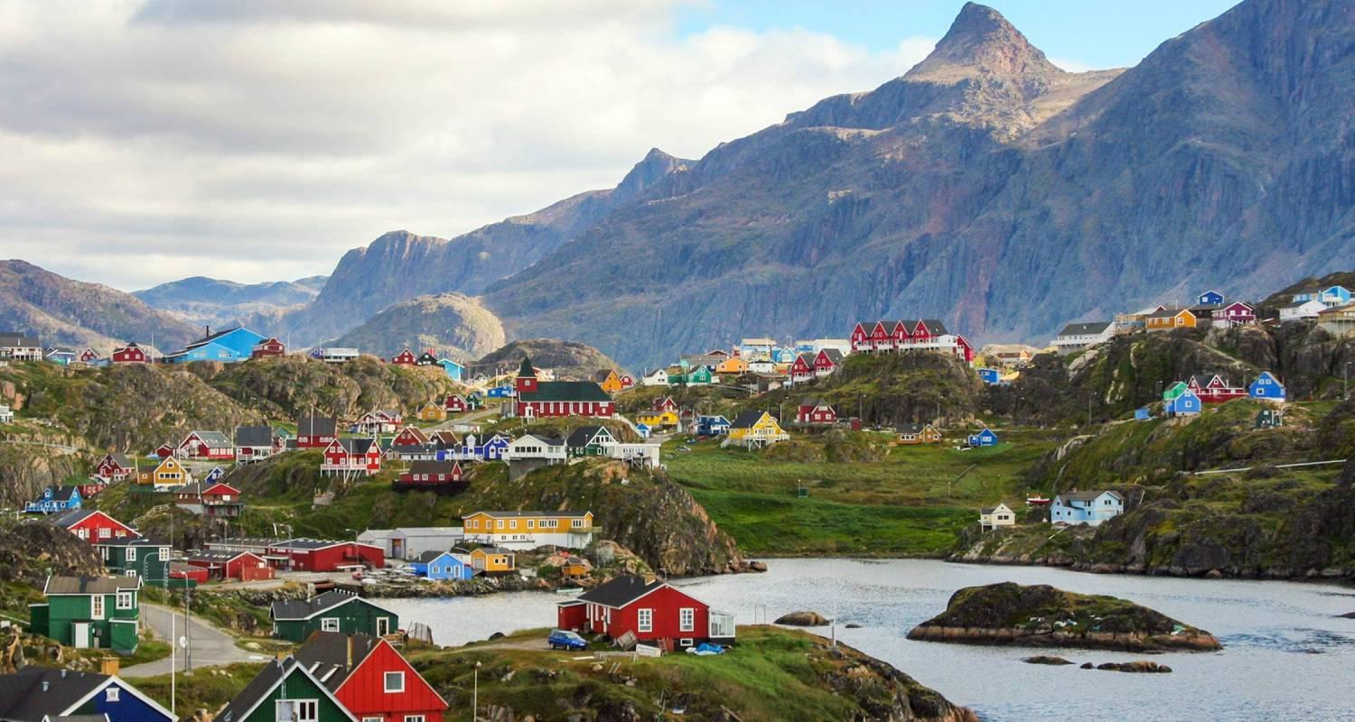

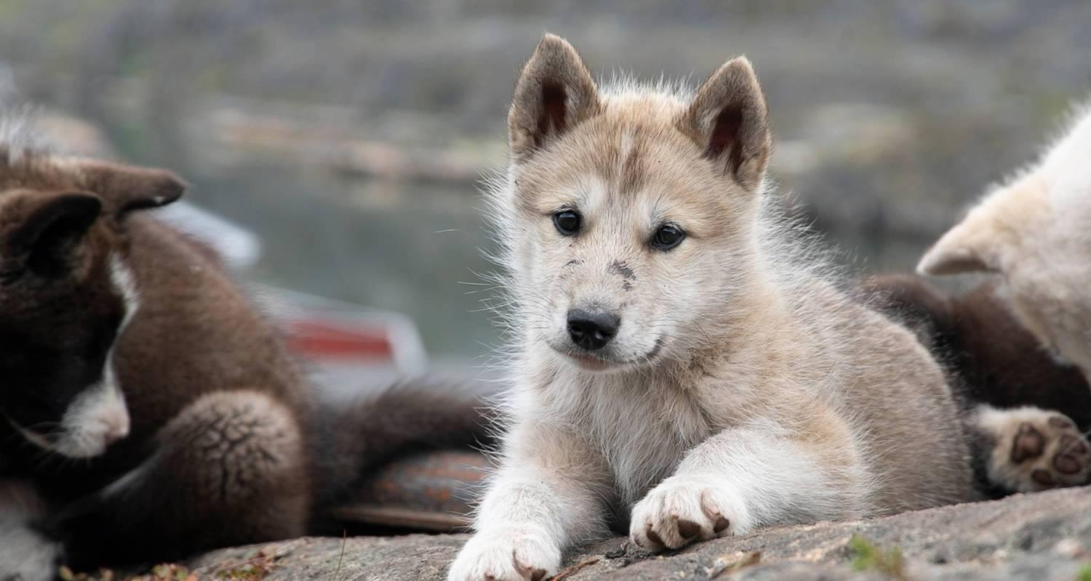

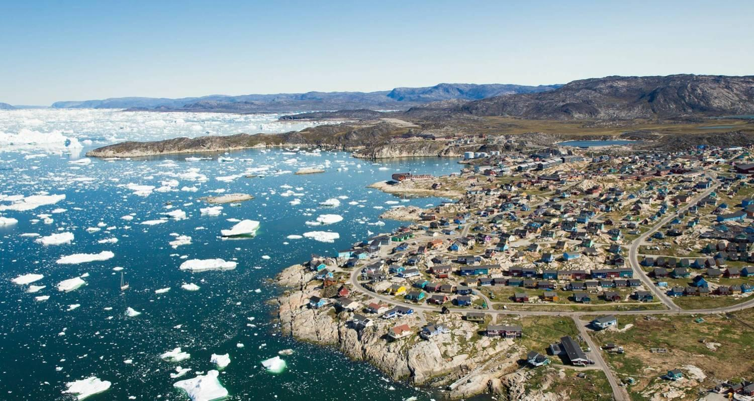

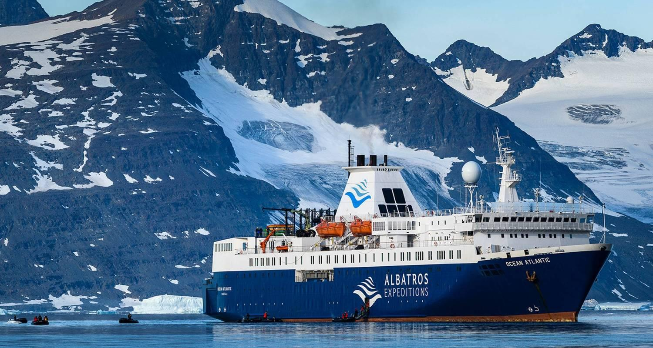

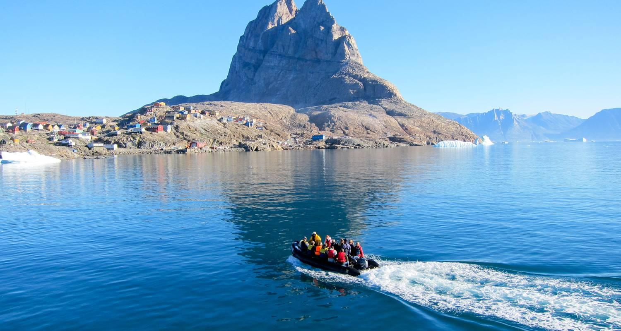

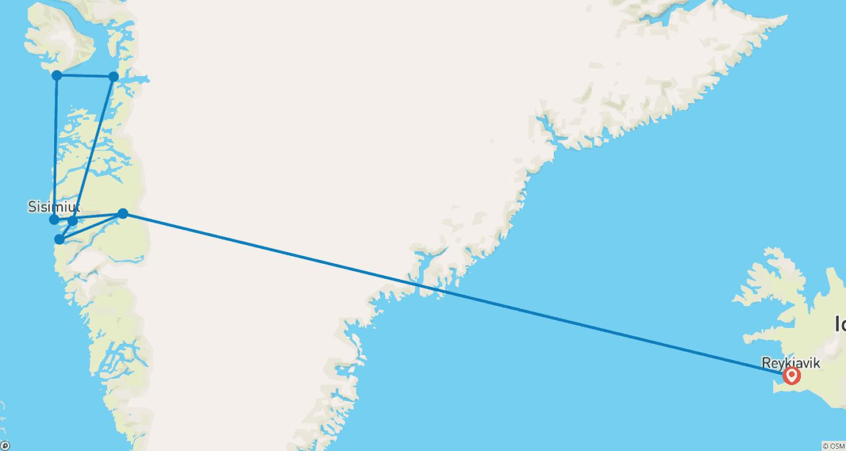

Tour ID: 219047  
Tour Name: 12 Days Grand Tour of Iceland

Tour destinations: ['Reykjavik', 'Gullfoss', 'Geysir', 'Thingvellir National Park', 'Borgarnes', 'Arnarstapi', 'Hellnar', 'Snaefellsjokull National Park', 'Stykkisholmur', 'Flatey', 'Hnjotur', 'Latrabjarg', 'Patreksfjordur', 'Bildudalur', 'Budardalur', 'Hvammstangi', 'Hvitserkur', 'Akureyri', 'Siglufjordur', 'Godafoss', 'Myvatn', 'Skutustadagigar', 'Hverfjall Volcano', 'Mount Namaskard', 'Krafla Volcano', 'Dettifoss', 'Bakkagerdi', 'Egilsstadir', 'Stodvarfjordur', 'Hofn', 'Jokulsarlon', 'Skaftafell', 'Vik', 'Reynisfjara', 'Reynisdrangar Cliffs', 'Skogafoss', 'Eyjafjallajokull', 'Seljaland']

Tour destinations images:

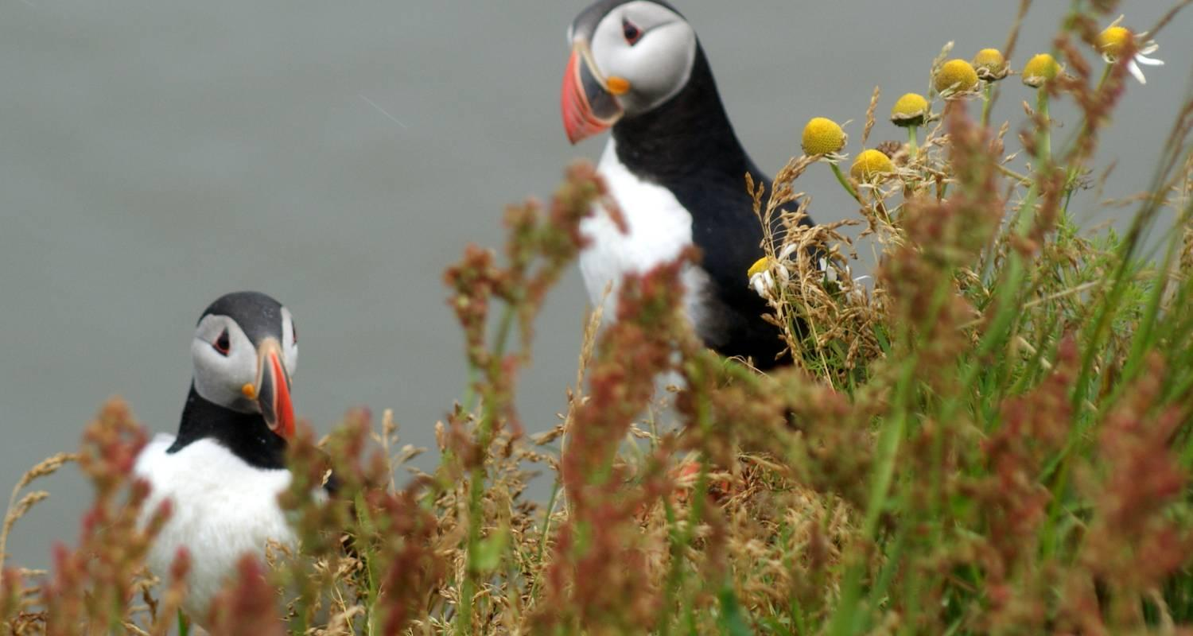

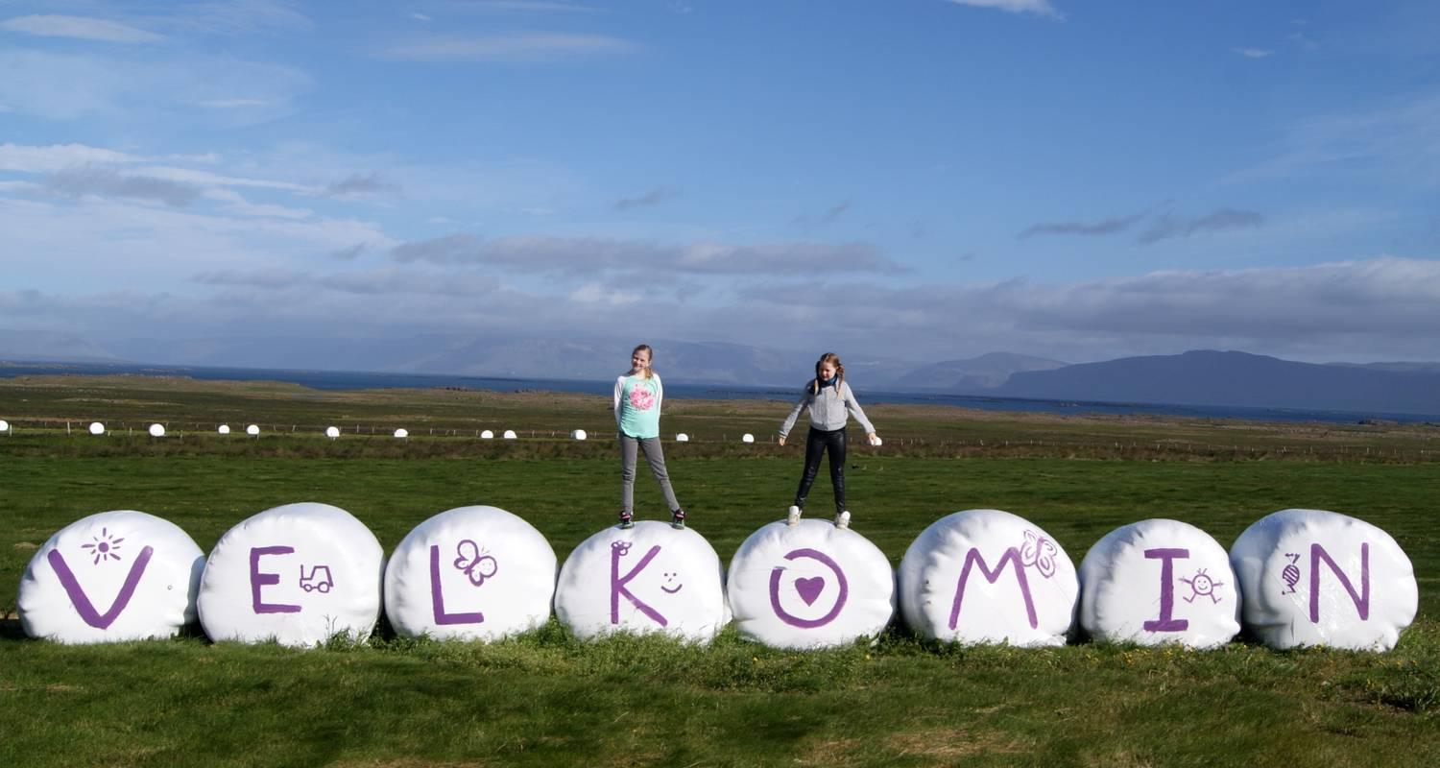

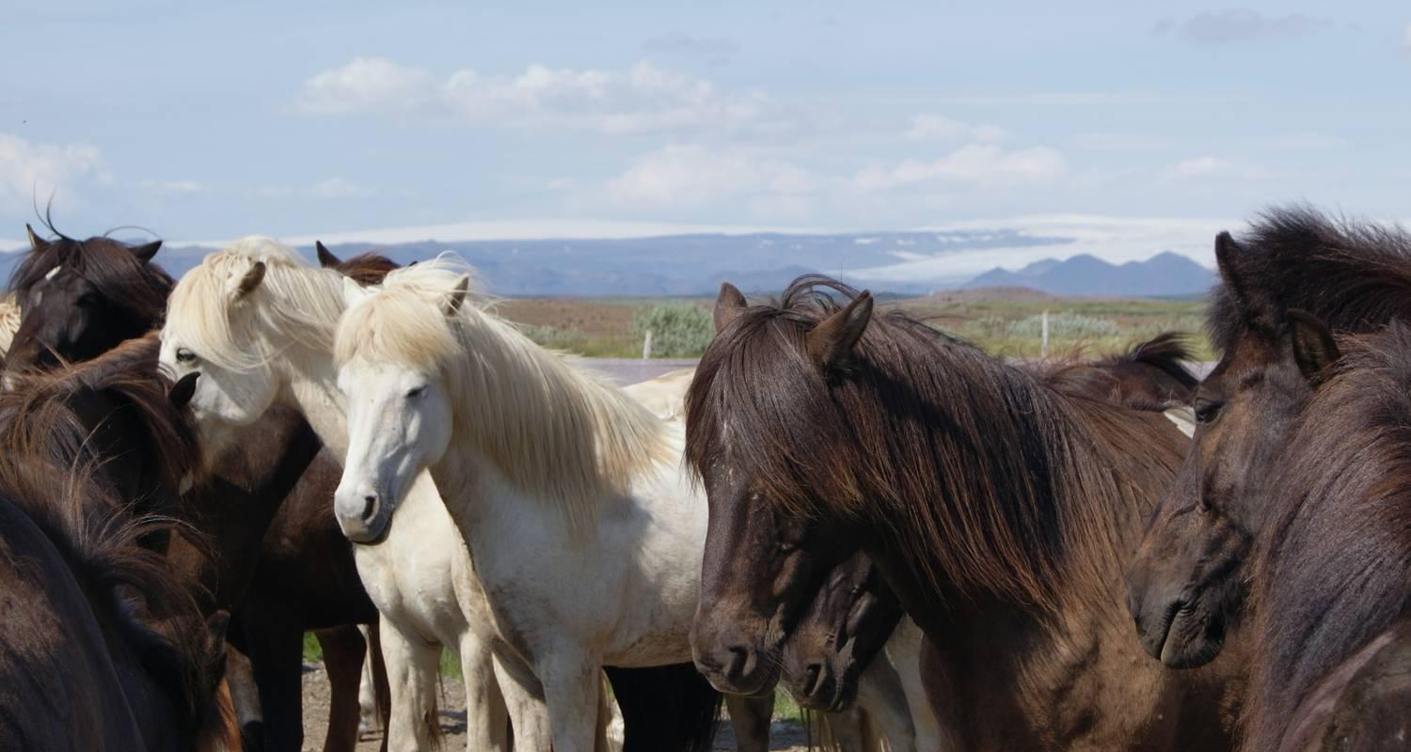

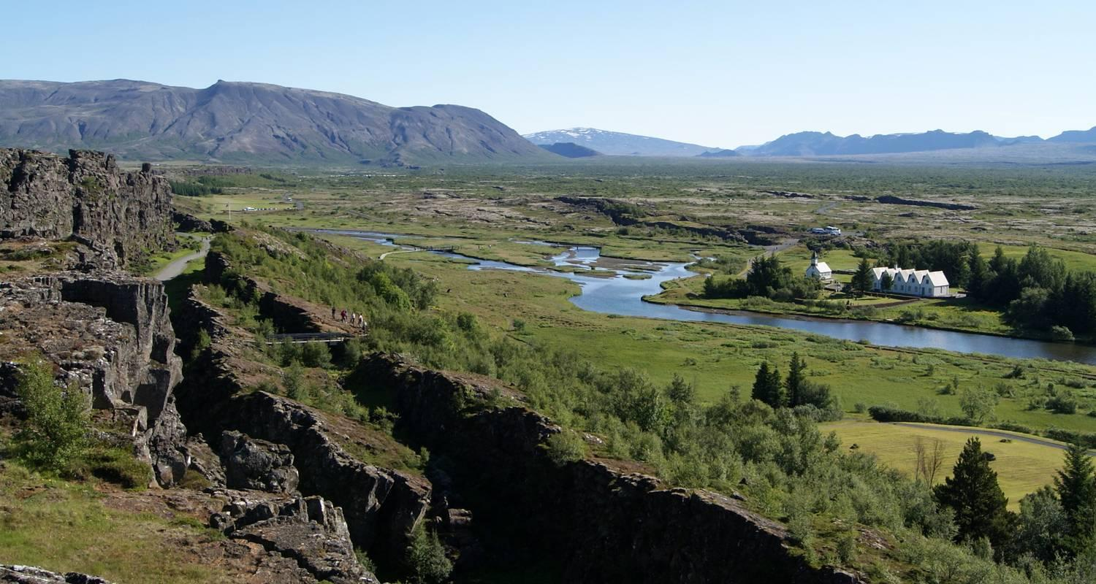

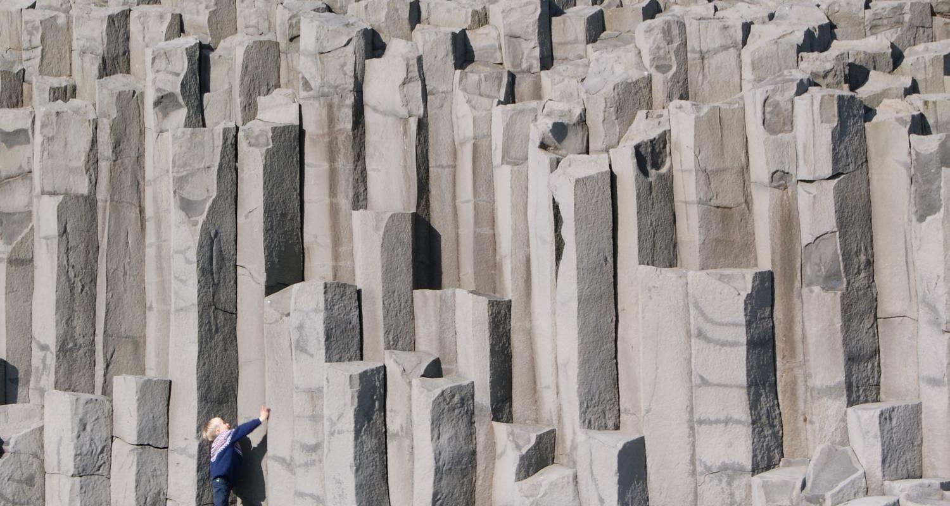

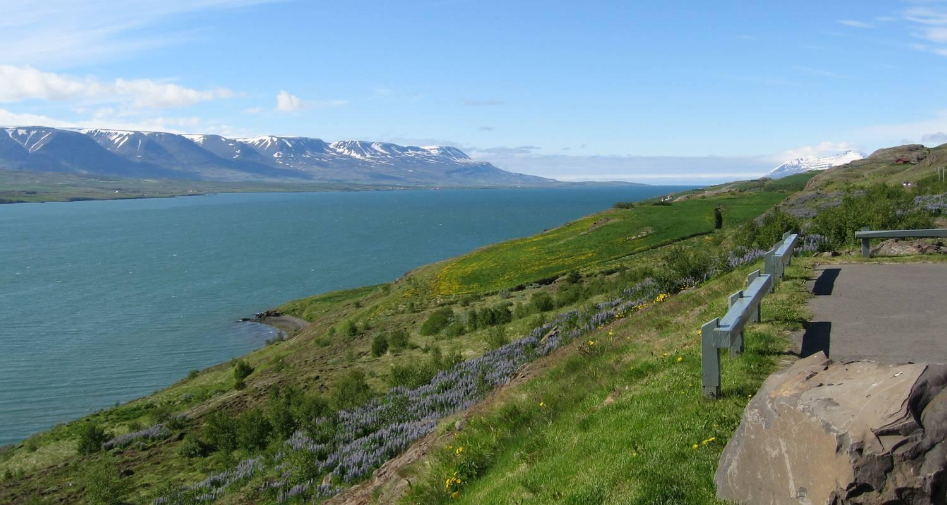

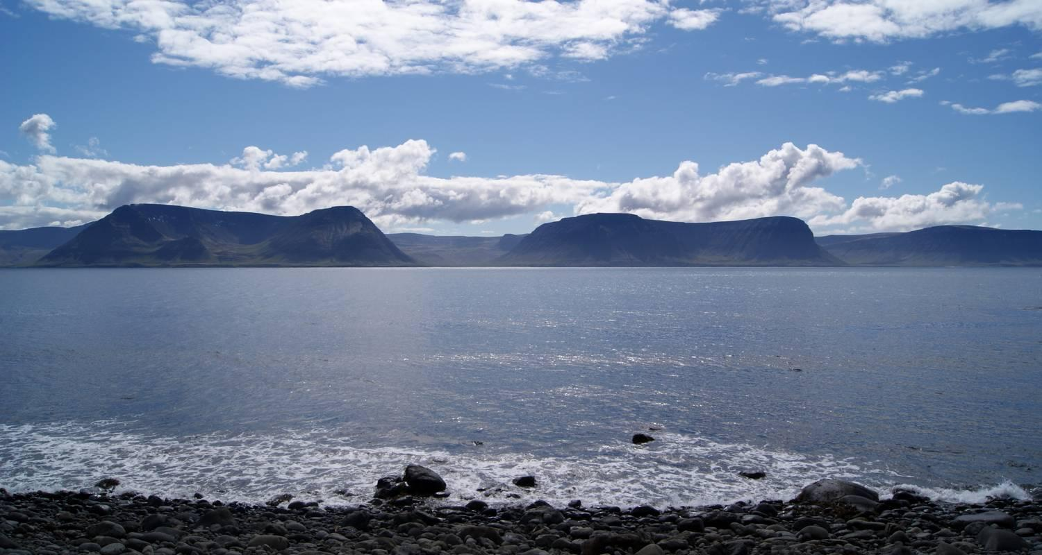

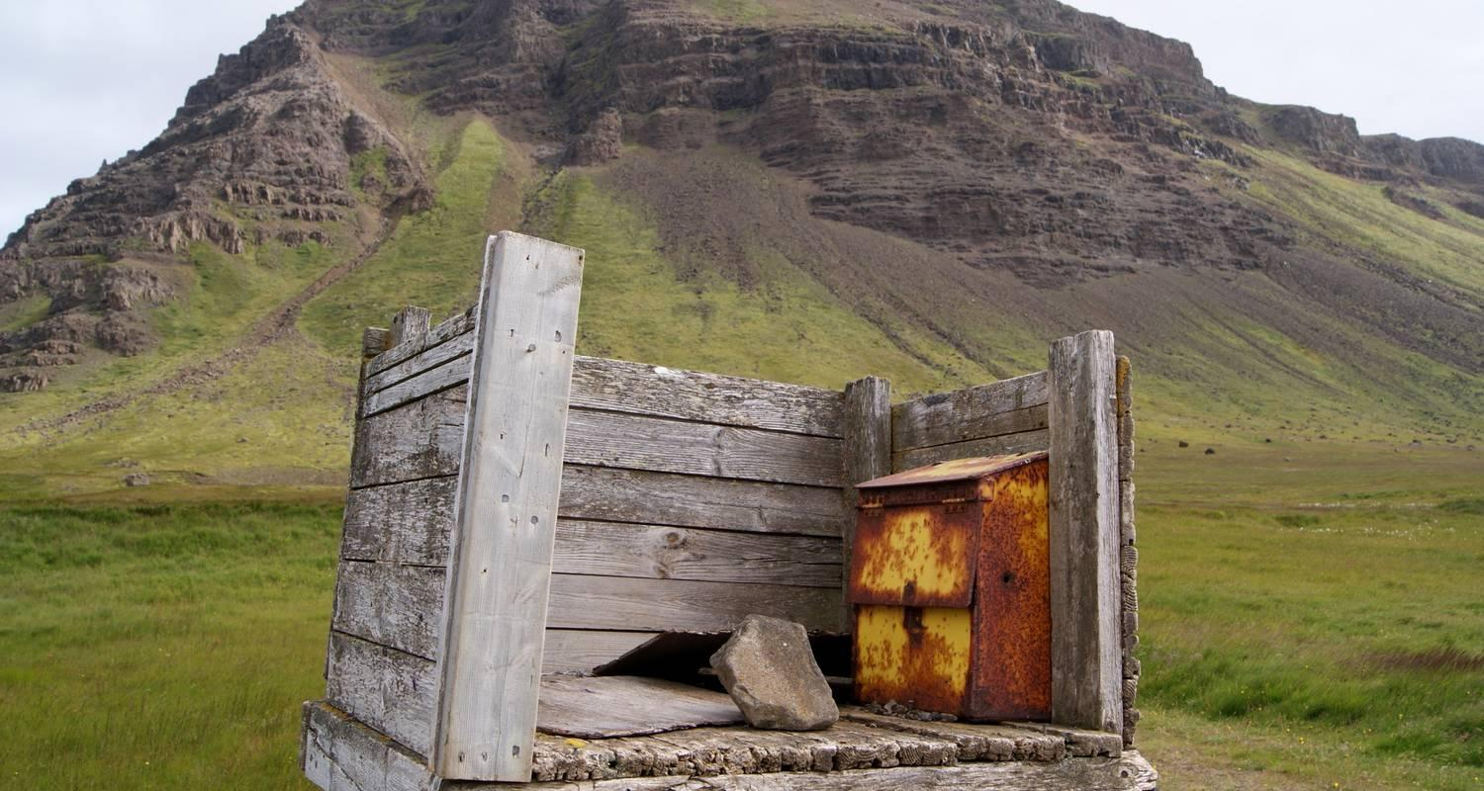

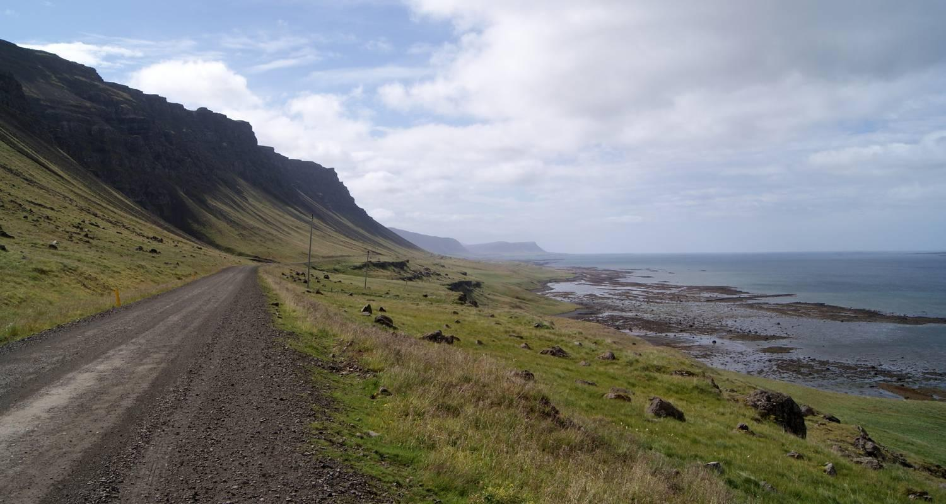

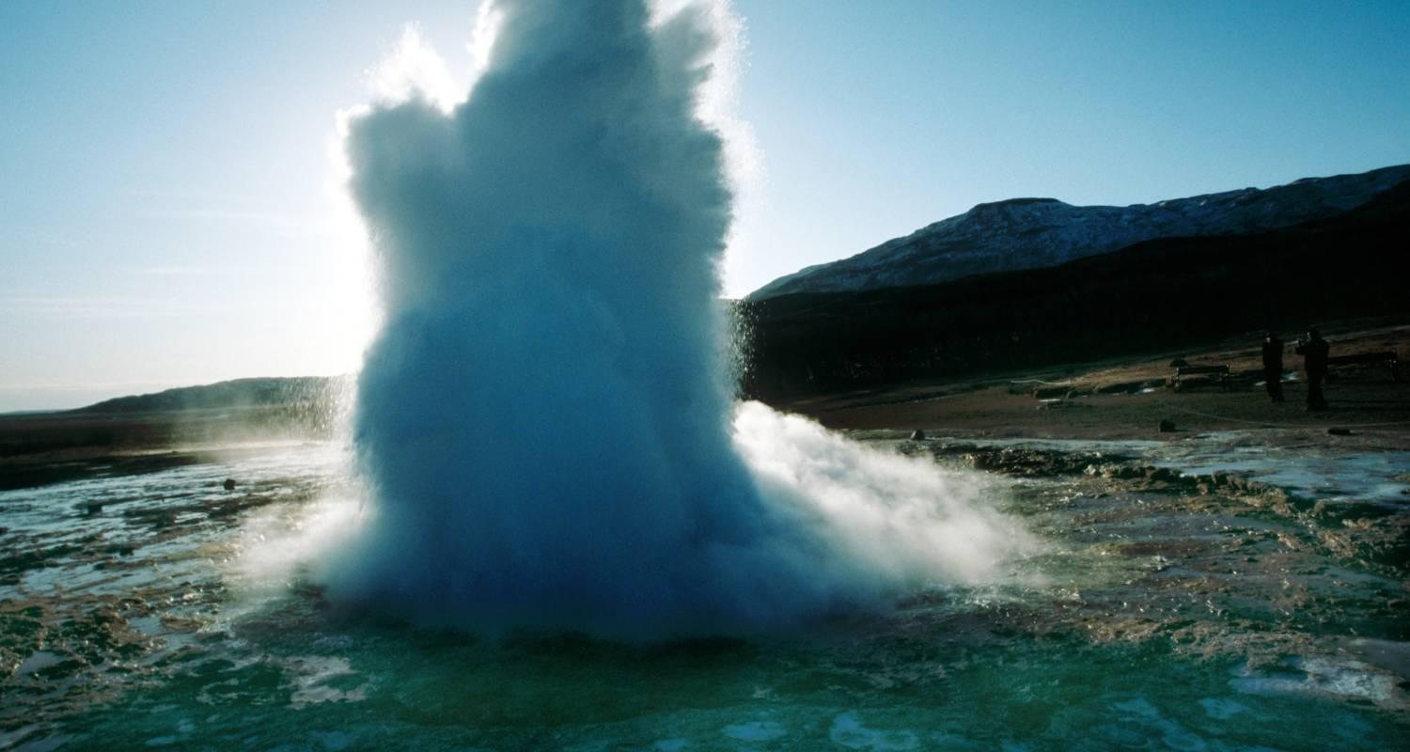

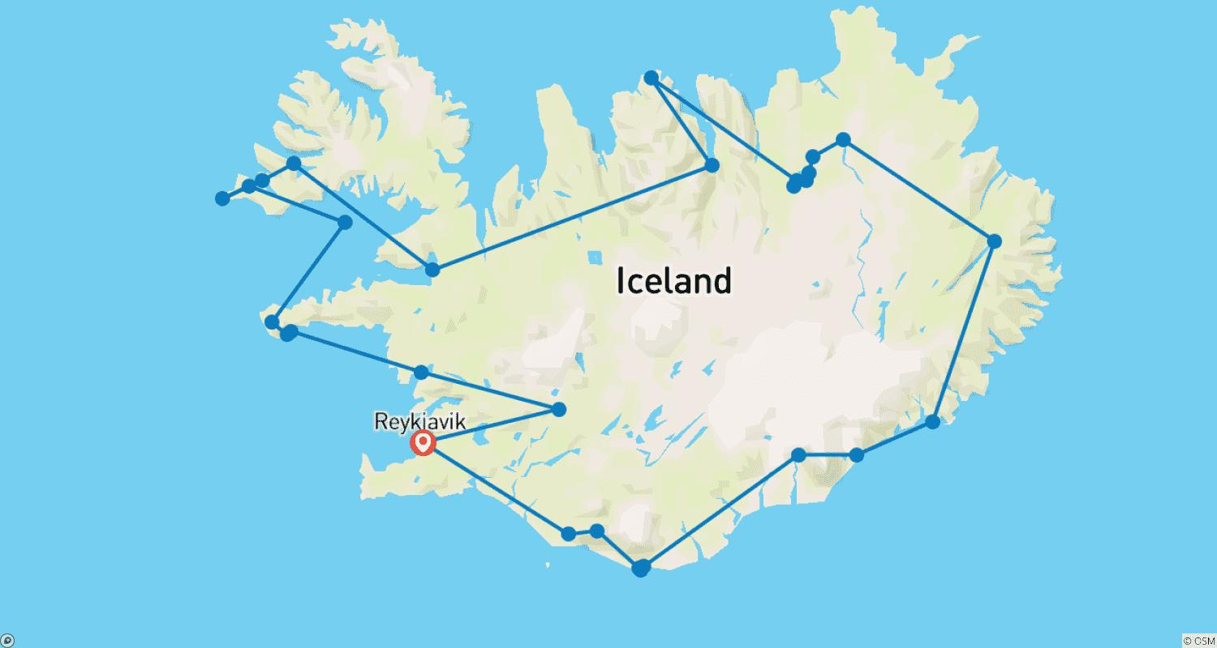

Tour ID: 219843  
Tour Name: 3 Days Gems of South Iceland

Tour destinations: ['Reykjavik', 'Heimaey Island', 'Seljaland', 'Skogafoss', 'Eyjafjallajokull', 'Vik', 'Reynisfjara', 'Solheimajokull', 'Landmannalaugar']

Tour destinations images:

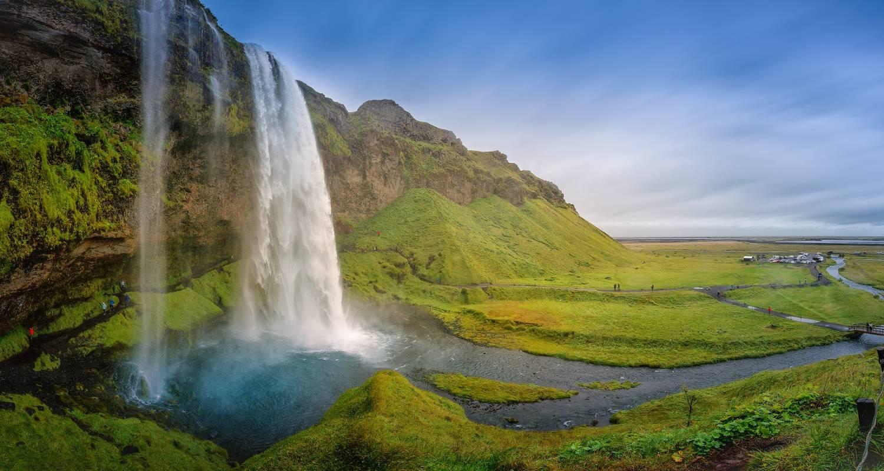

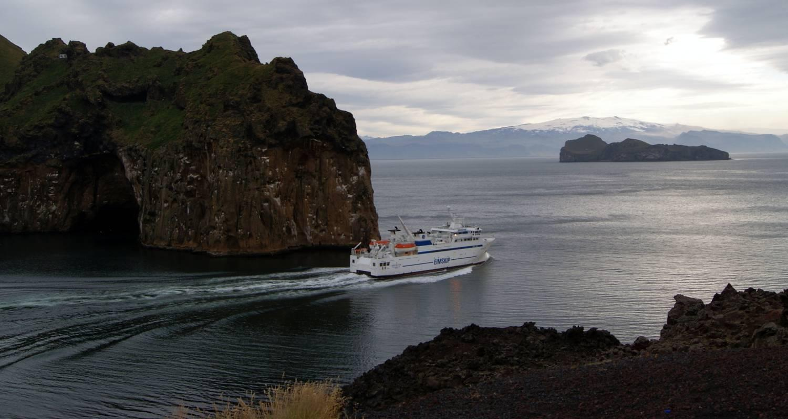

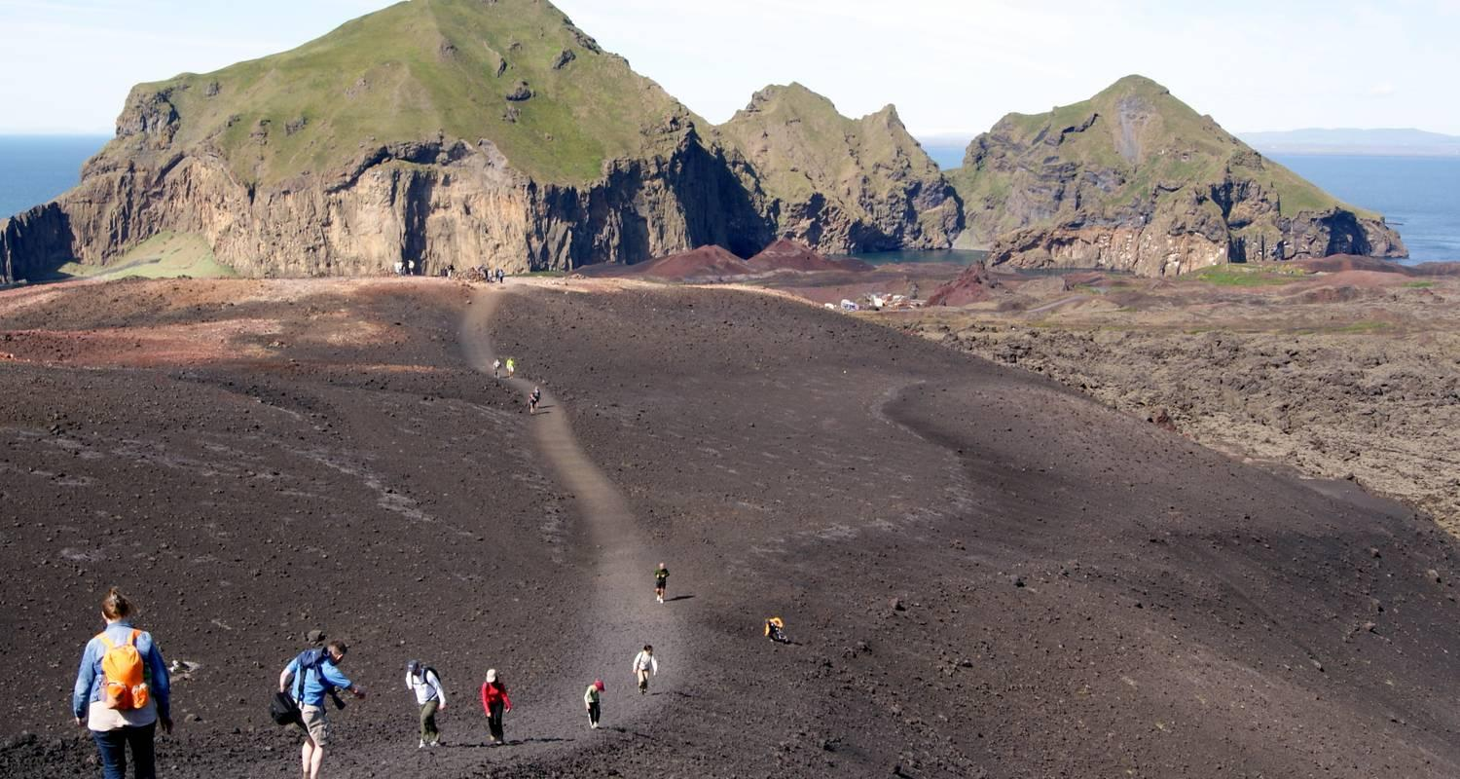

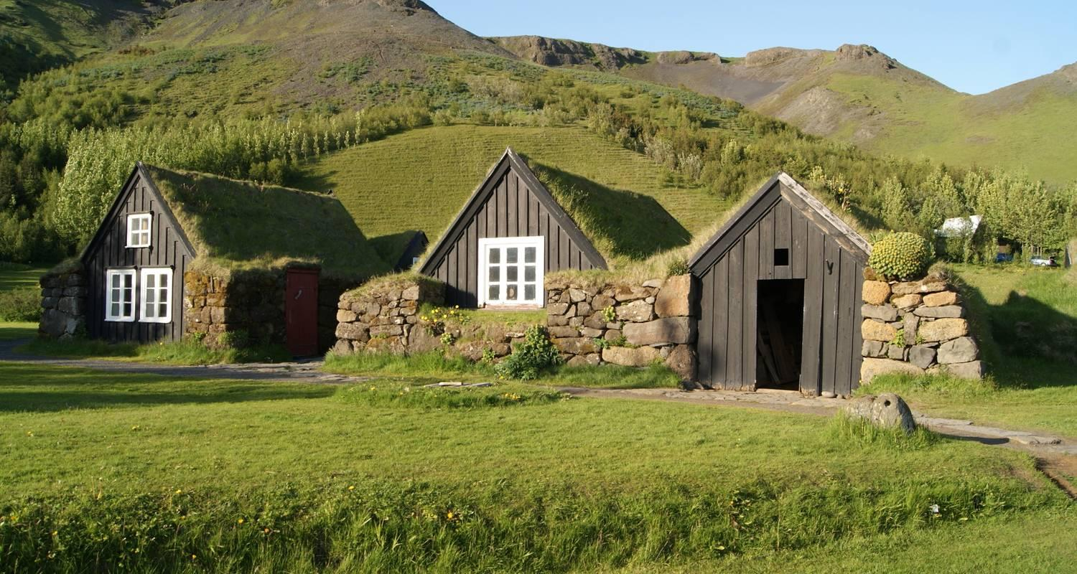

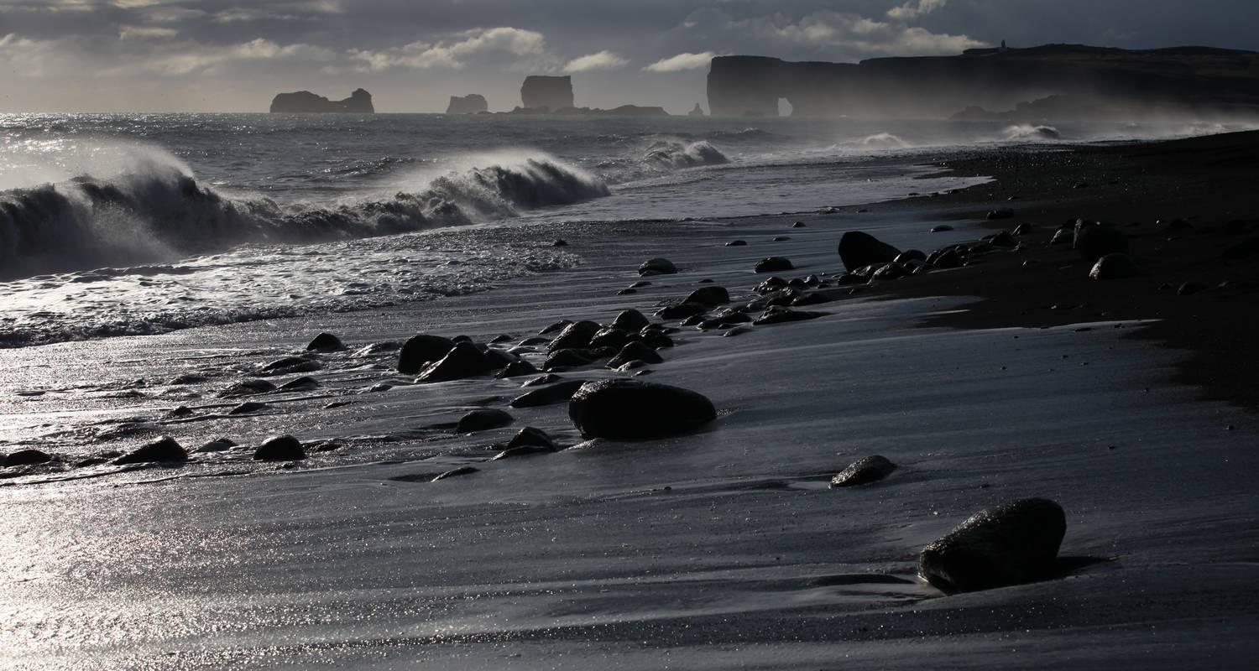

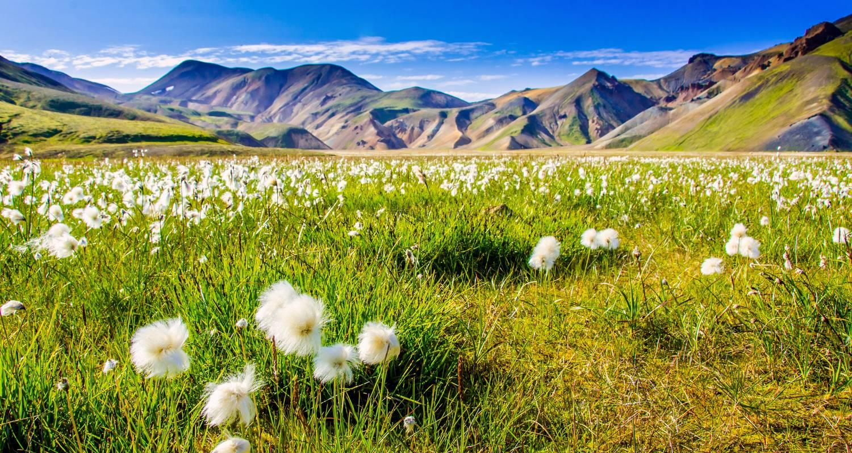

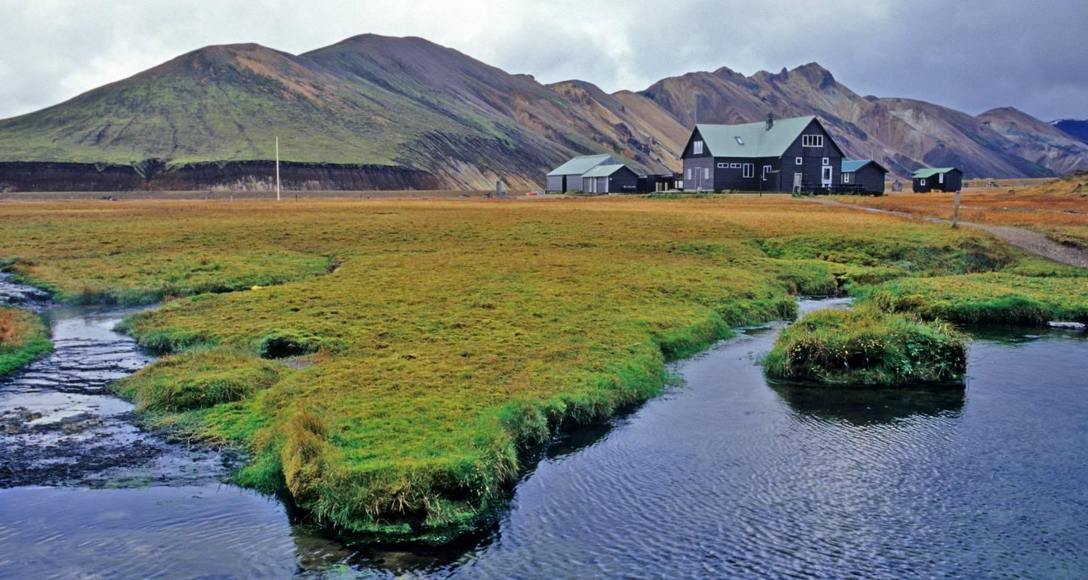

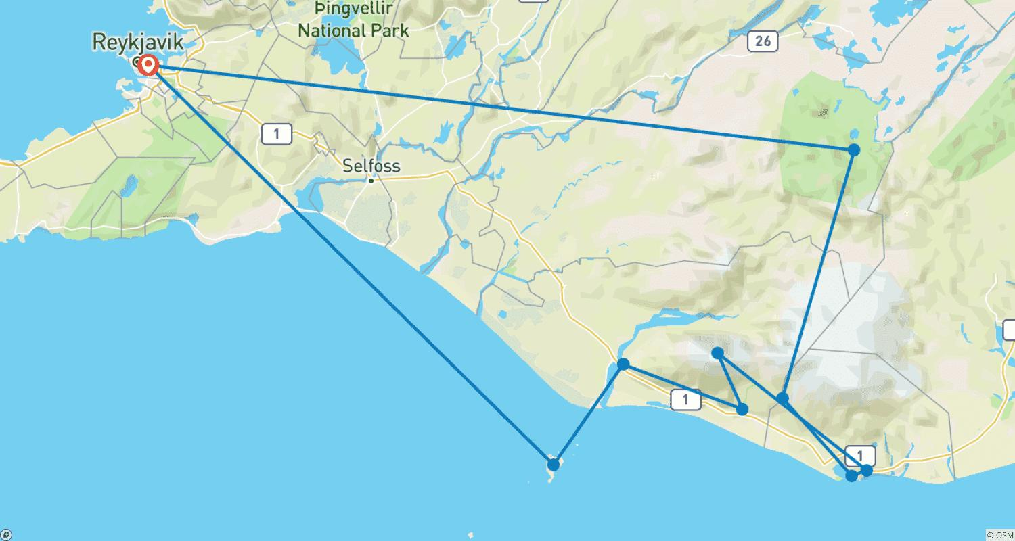

Tour ID: 219845  
Tour Name: 6 Days Gems of South Iceland & Reykjavik

Tour destinations: ['Reykjavik', 'Heimaey Island', 'Seljaland', 'Skogafoss', 'Eyjafjallajokull', 'Vik', 'Reynisfjara', 'Solheimajokull', 'Landmannalaugar']

Tour destinations images:



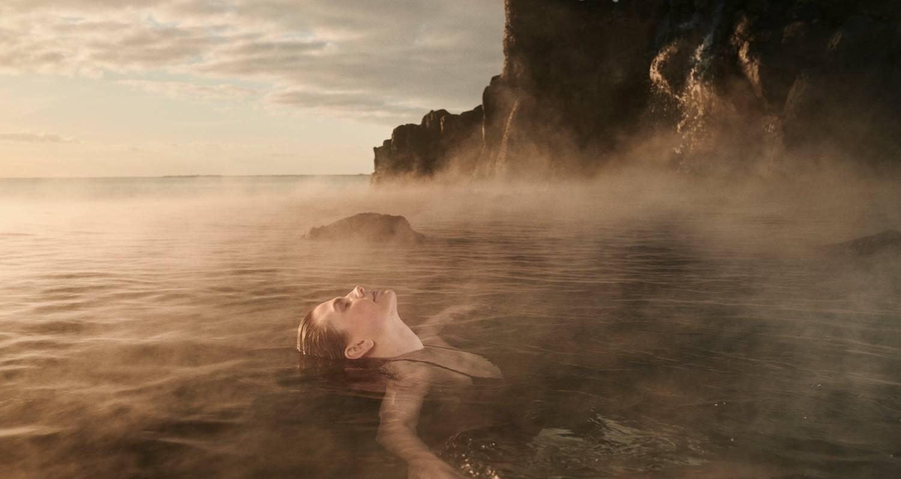

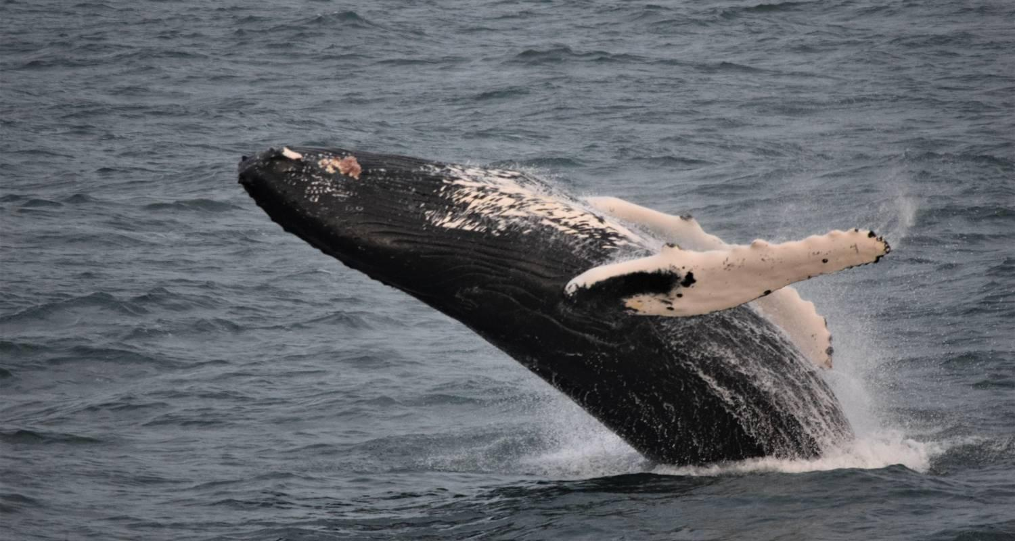















Tour ID: 220646  
Tour Name: 4 Day Winter Minibus Tour: Blue Ice Cave, South Coast, Golden Circle, Snaefellsnes & Northern Lights

Tour destinations: ['Reykjavik', 'Arnarstapi', 'Djupalonssandur', 'Kirkjufell Mountain', 'Geysir', 'Gullfoss', 'Thingvellir National Park', 'Seljaland', 'Skogafoss', 'Reynisfjara', 'Skaftafell', 'Jokulsarlon']

Tour destinations images:

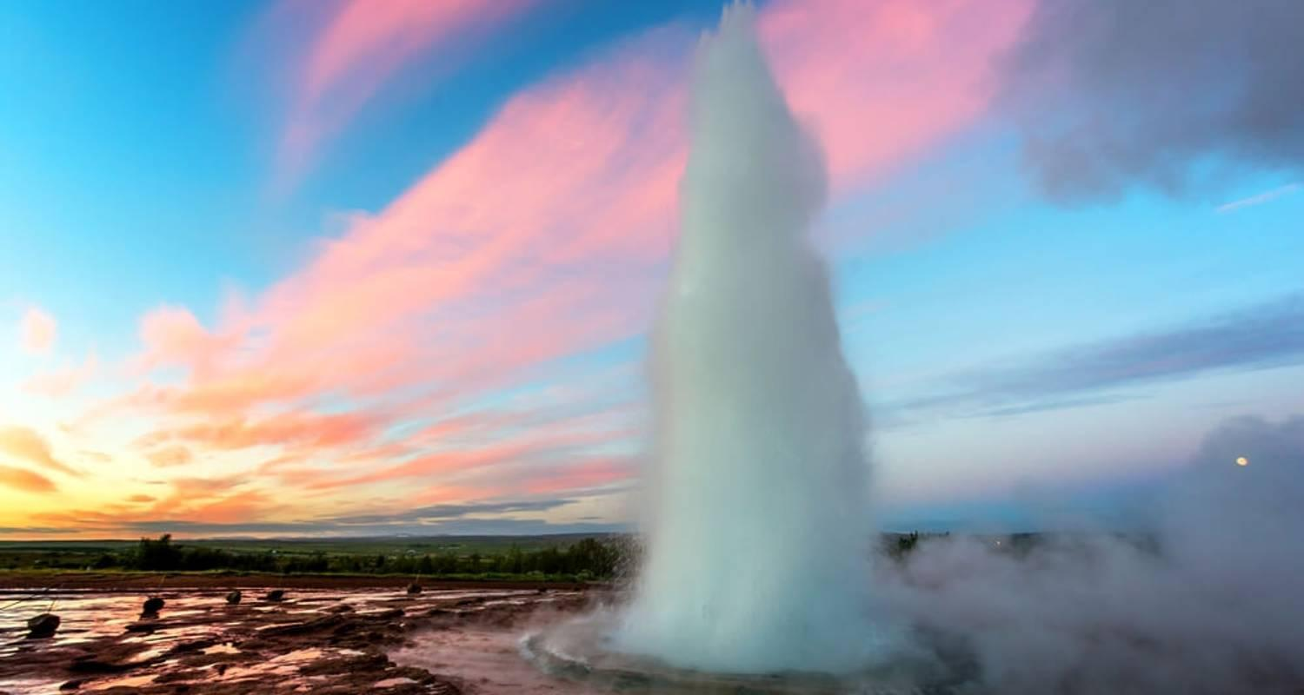

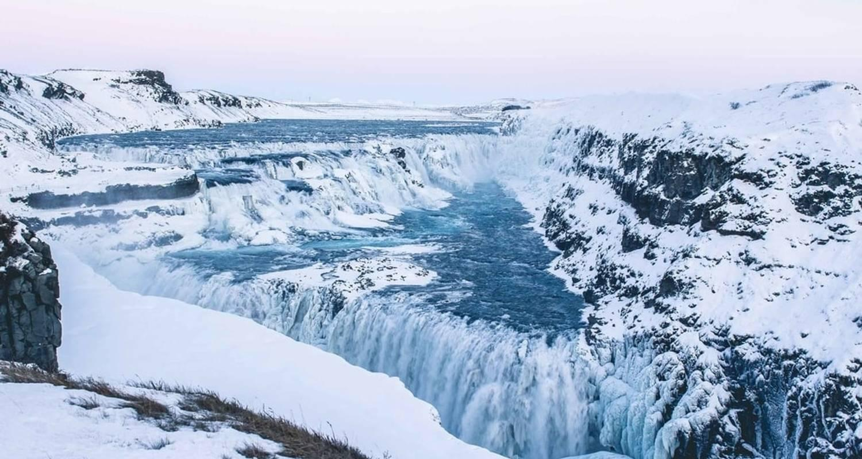

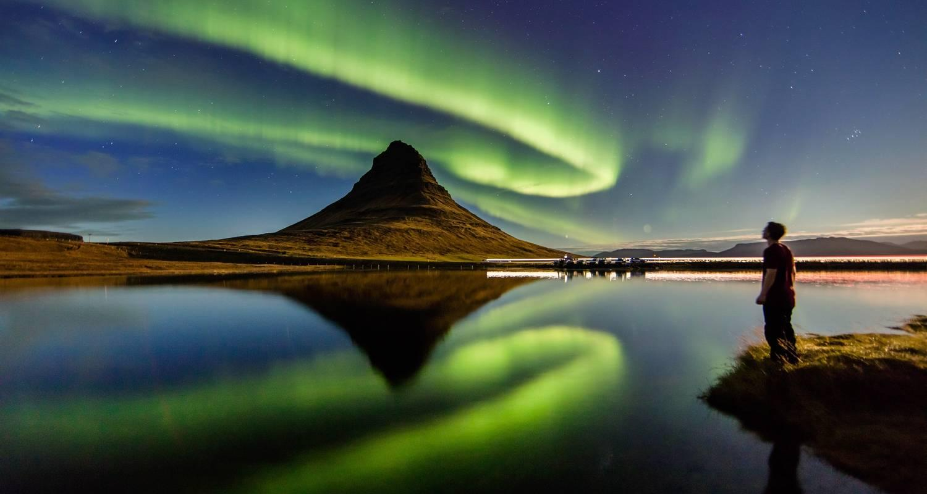

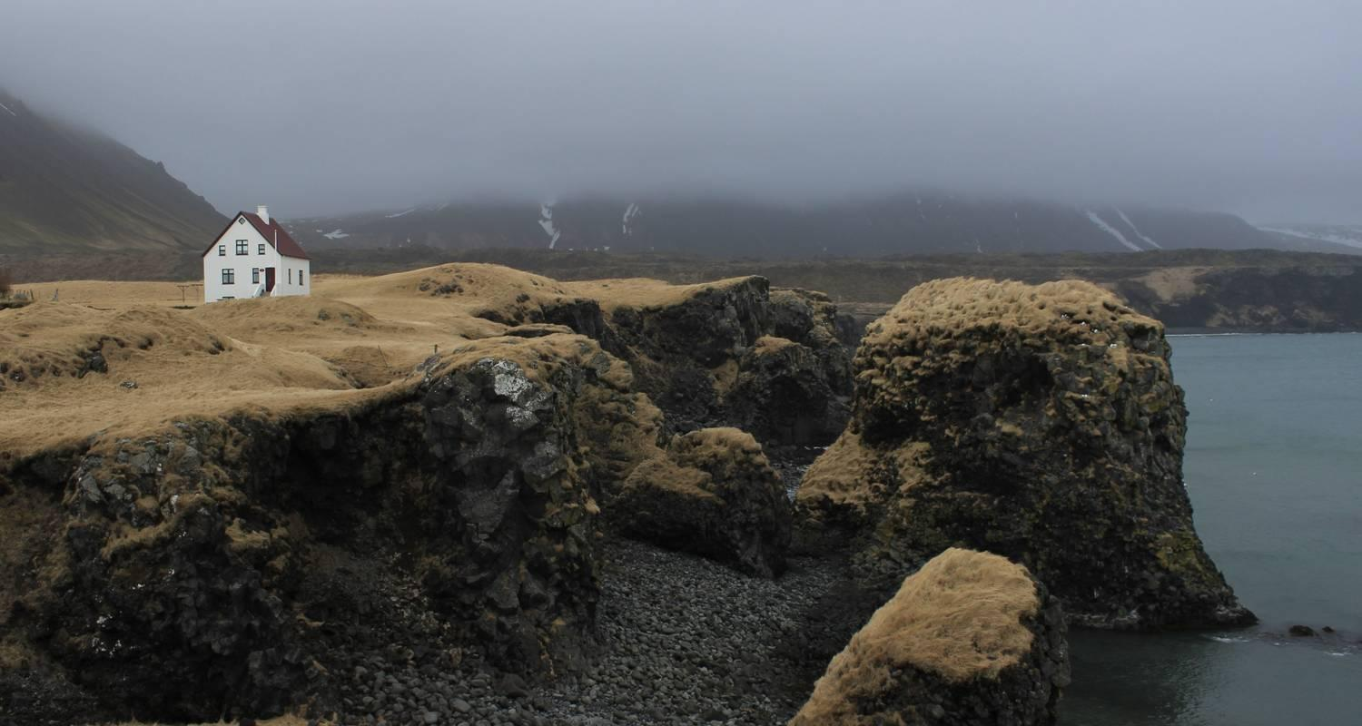

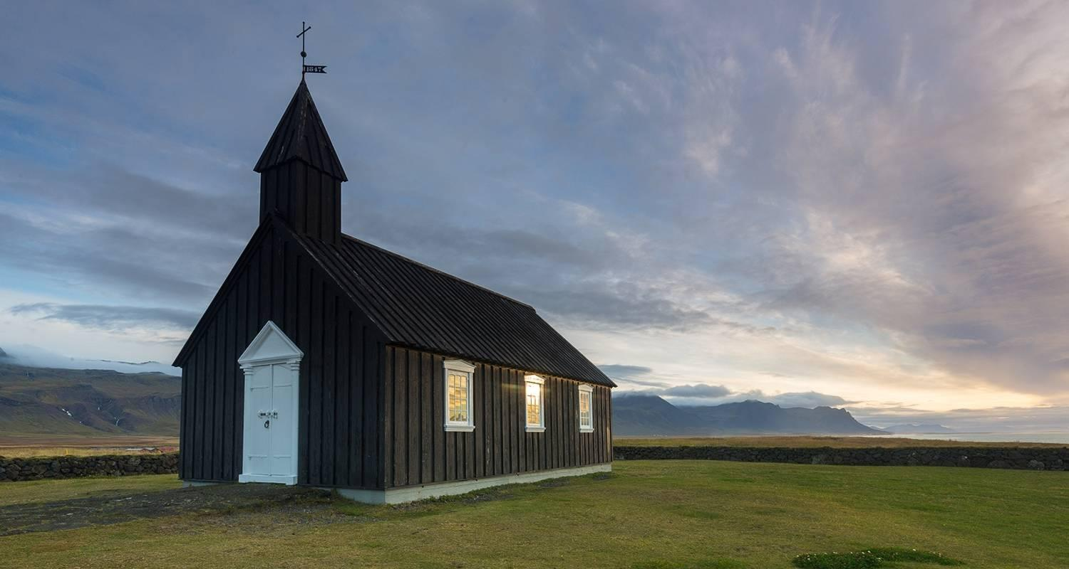

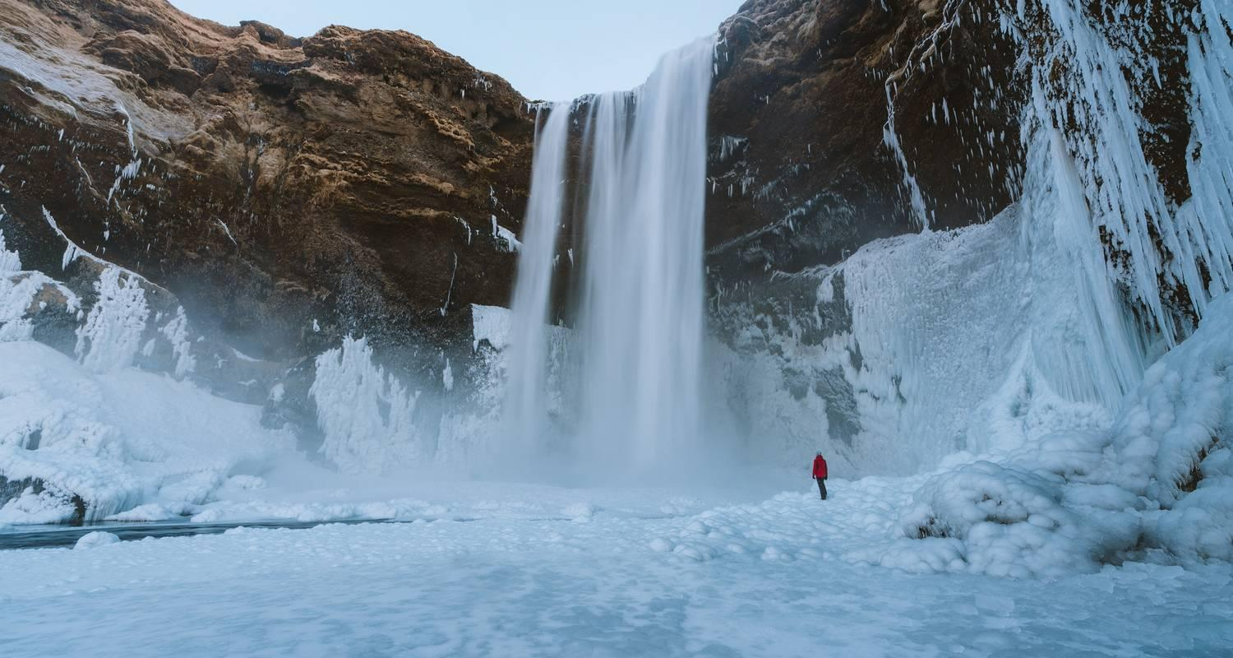

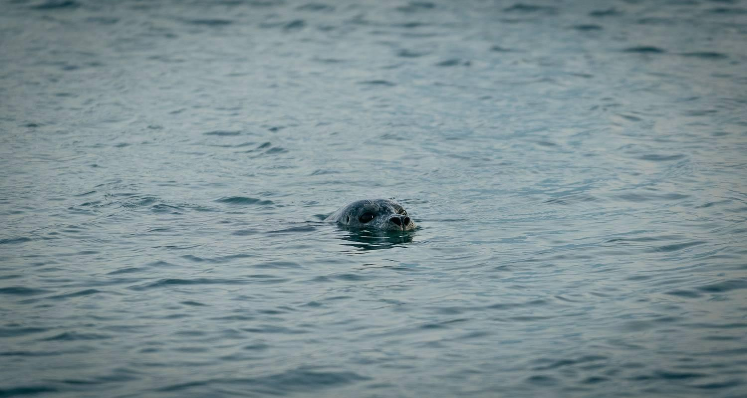

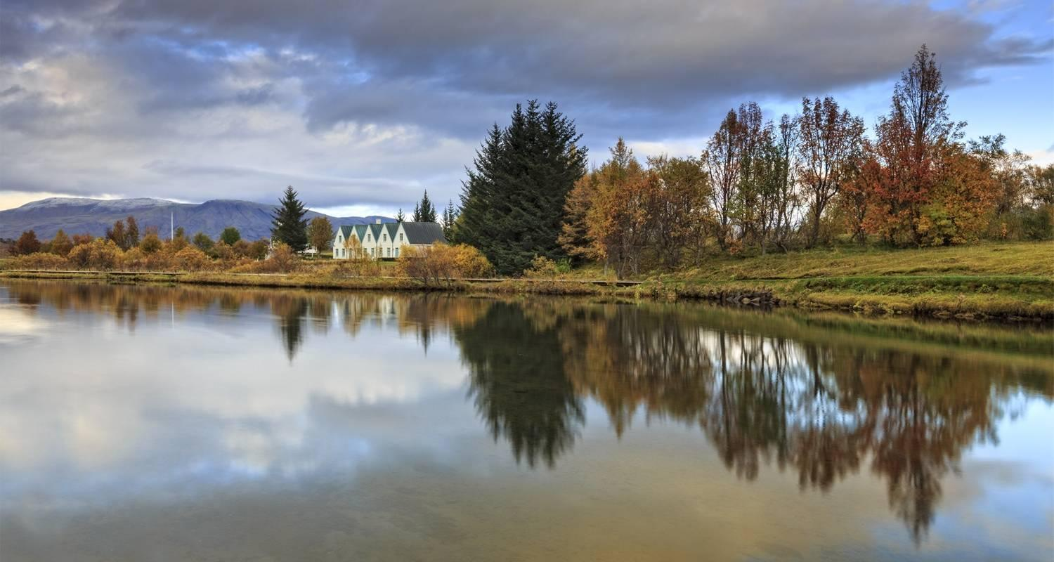

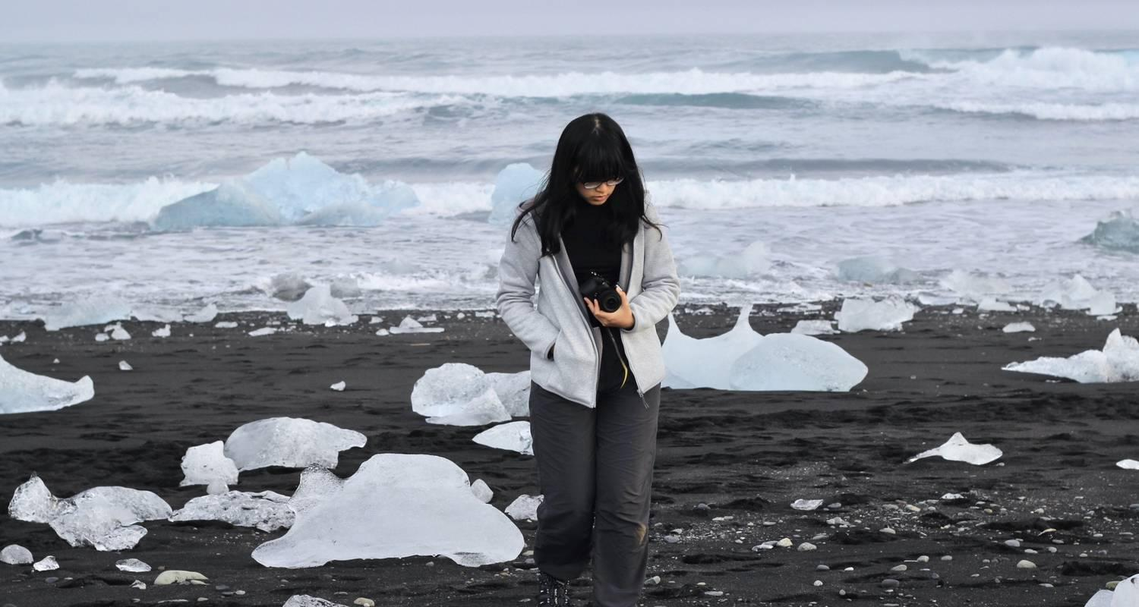

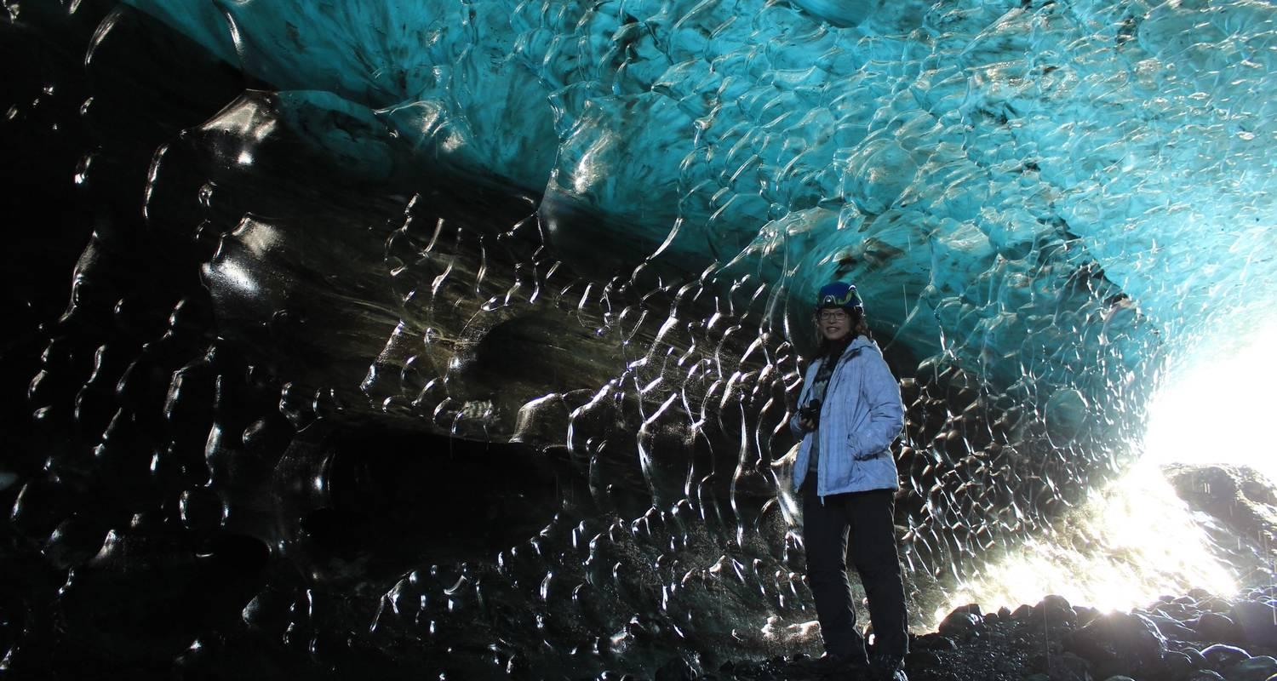

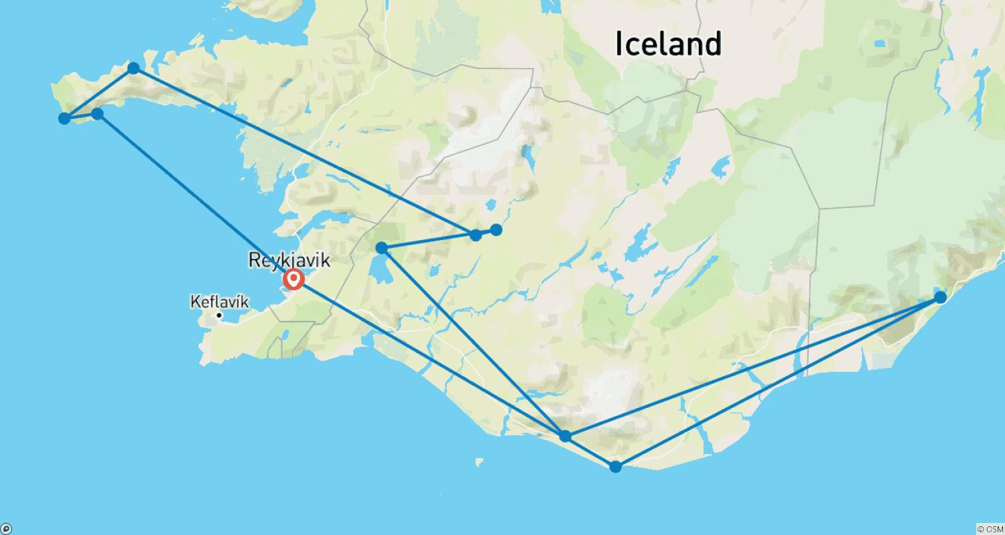

Tour ID: 220649  
Tour Name: 8 Day Around Iceland Summer Minibus Tour

Tour destinations: ['Reykjavik', 'Thingvellir National Park', 'Geysir', 'Gullfoss', 'Seljaland', 'Skogafoss', 'Reynisfjara', 'Vik', 'Skaftafell', 'Jokulsarlon', 'Djupivogur', 'Egilsstadir', 'Myvatn', 'Dettifoss', 'Asbyrgi Canyon', 'Husavik', 'Godafoss', 'Akureyri', 'Blonduos', 'Borgarnes', 'Kirkjufell Mountain', 'Snaefellsjokull National Park', 'Hraunfossar', 'Reykholt']

Tour destinations images:

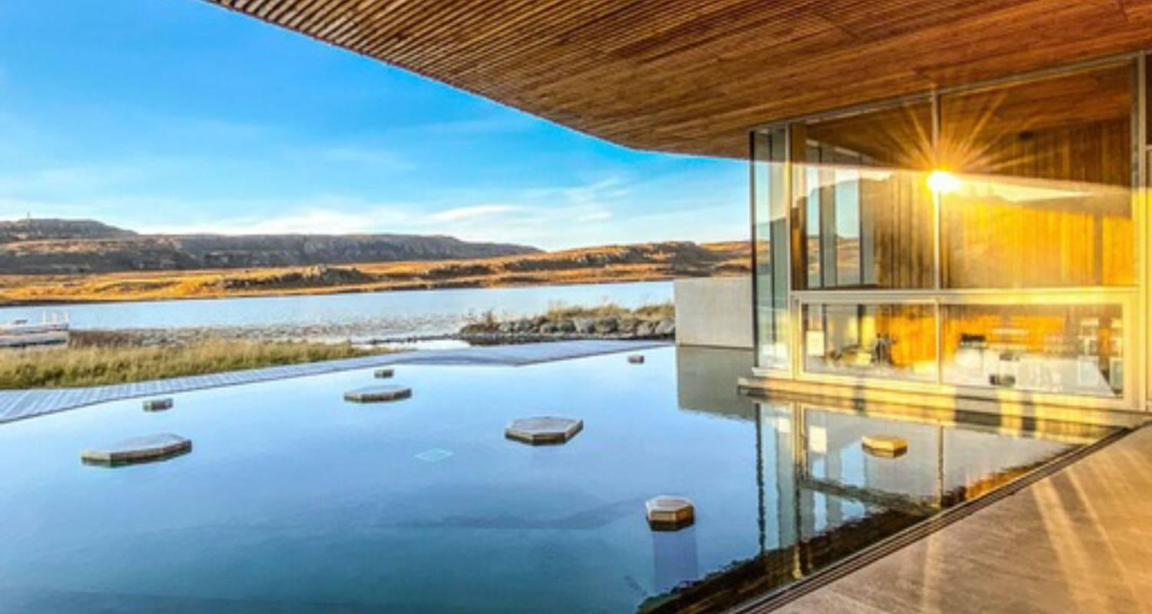

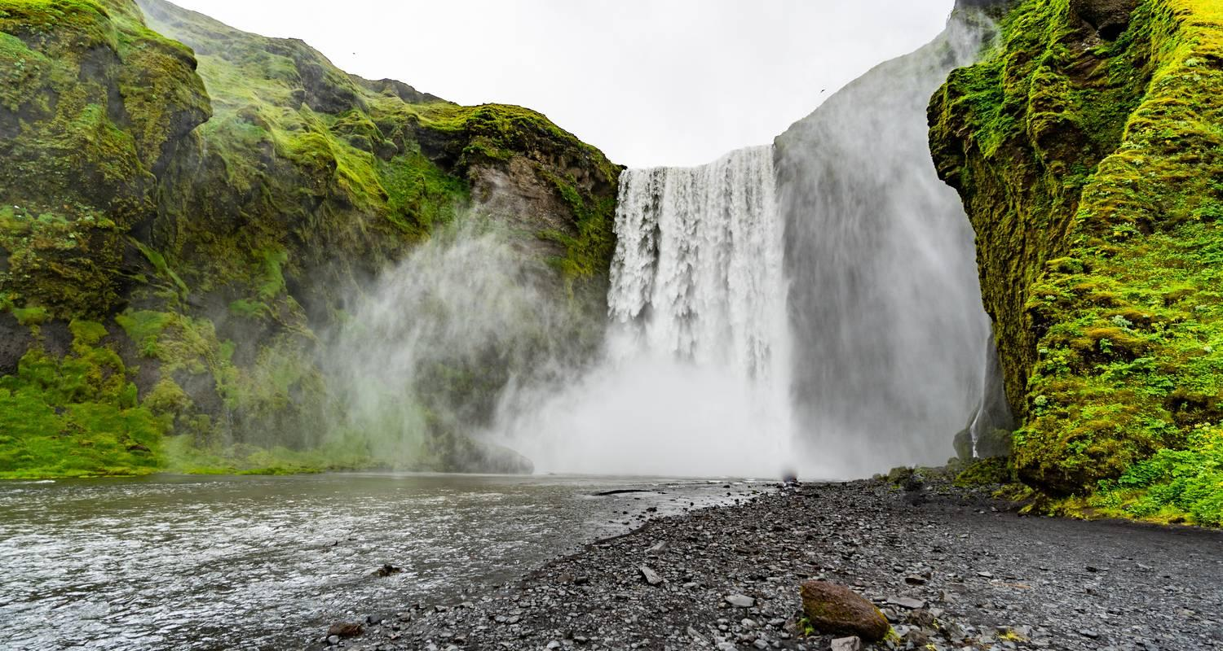

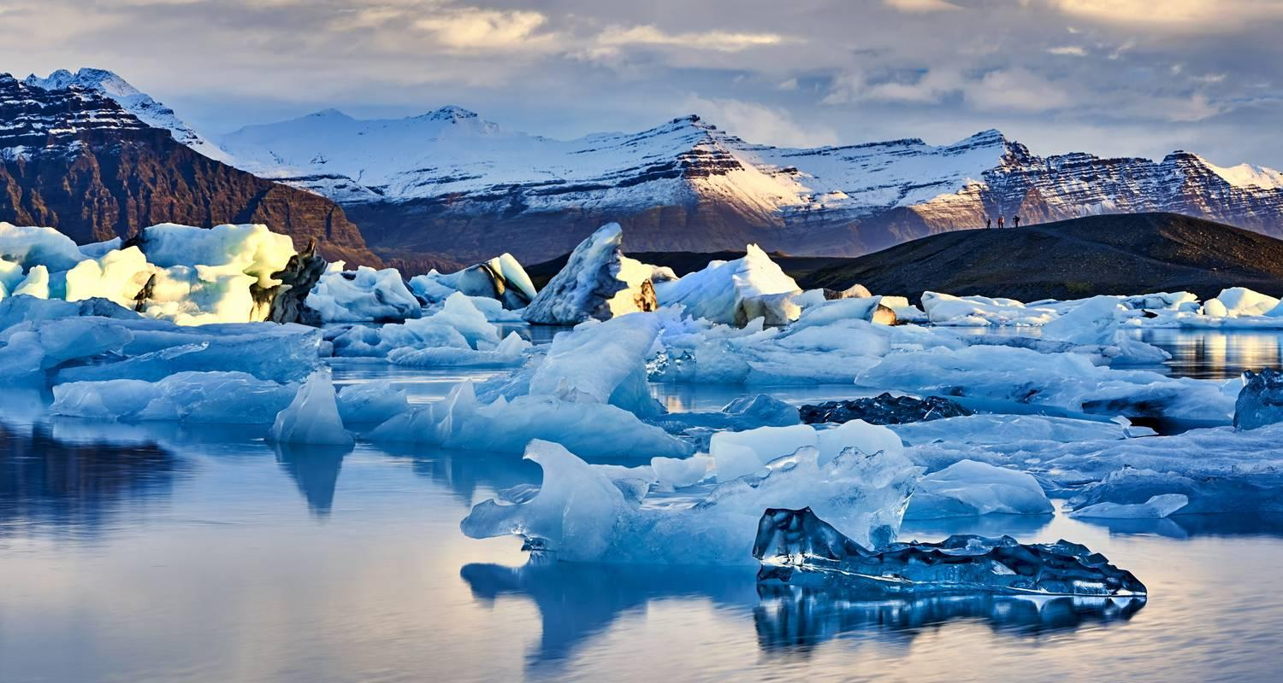

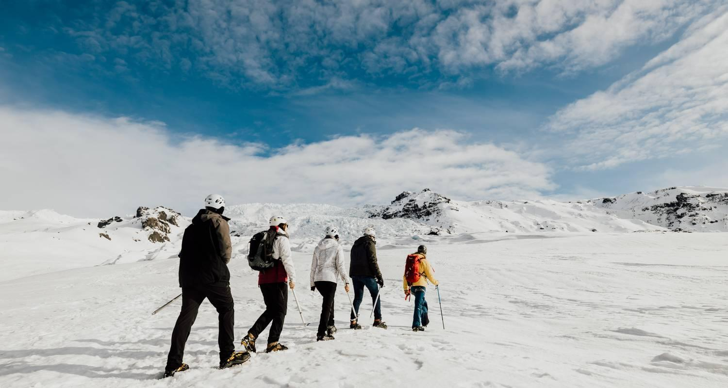

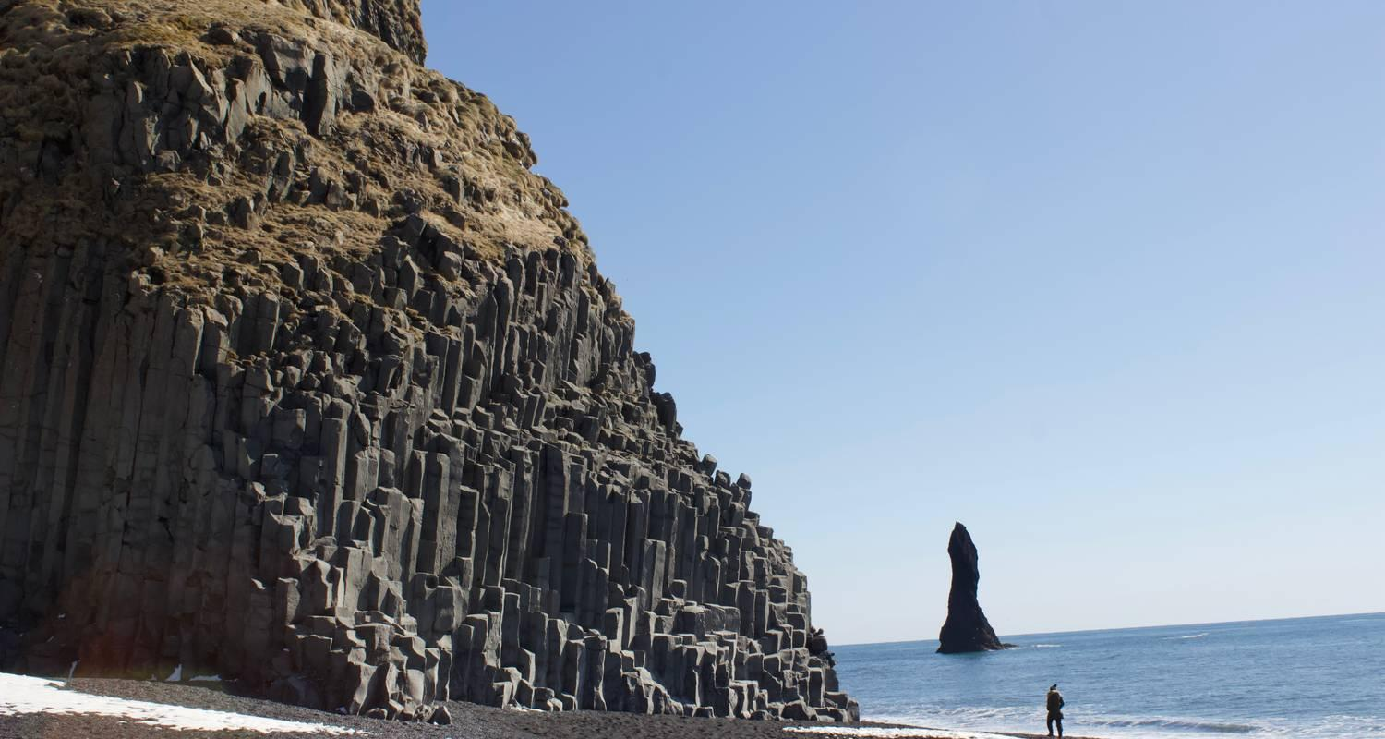

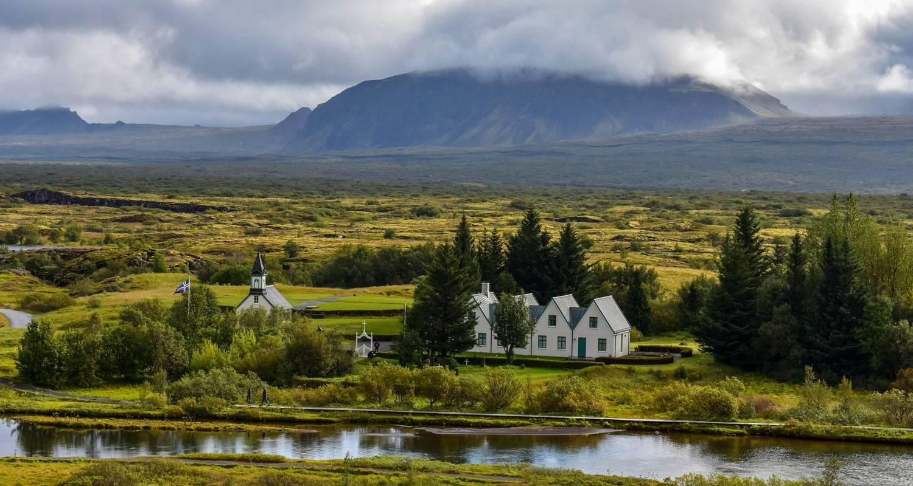

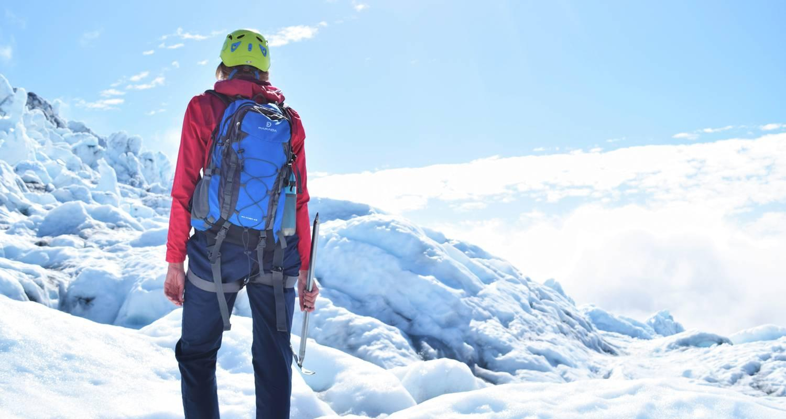

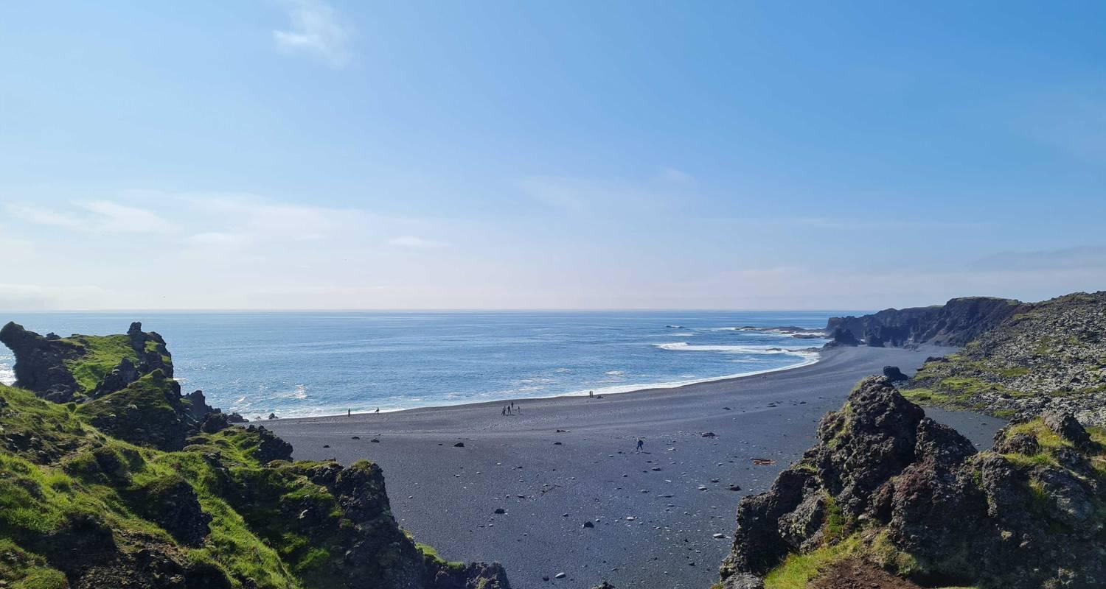

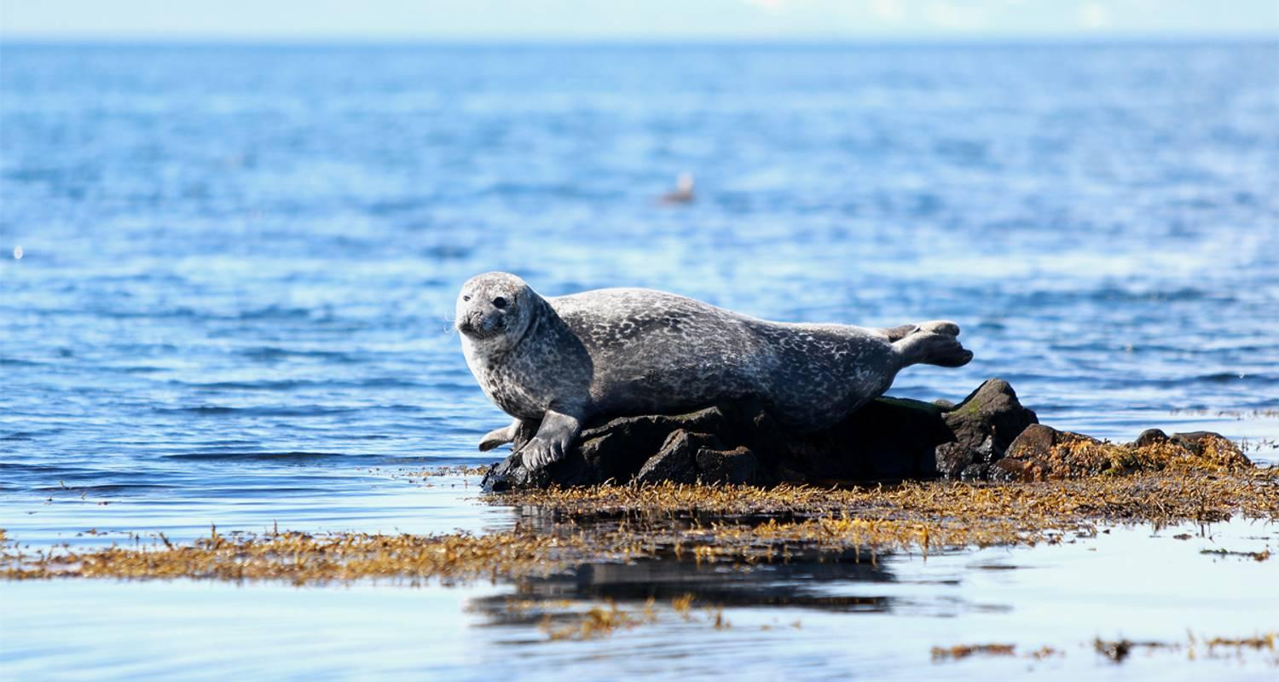

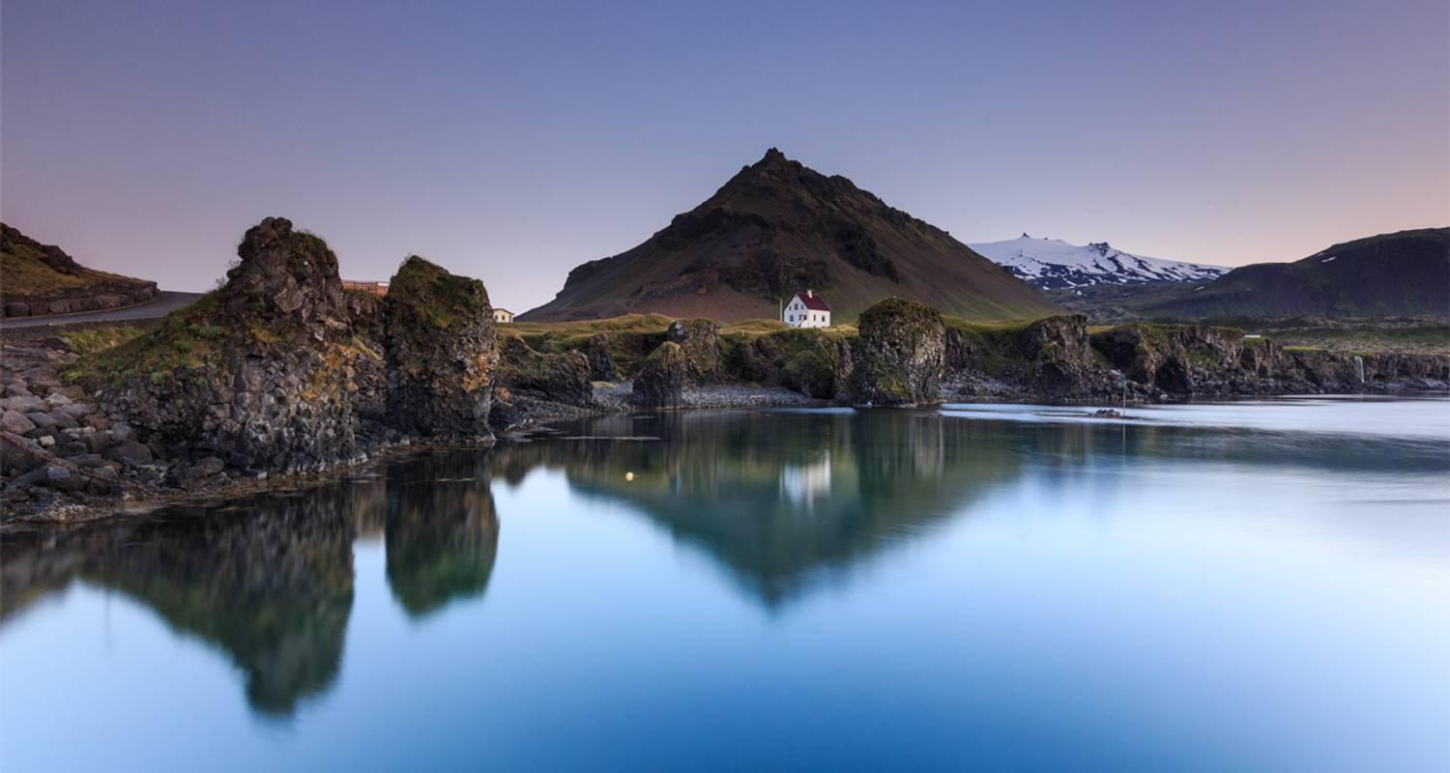

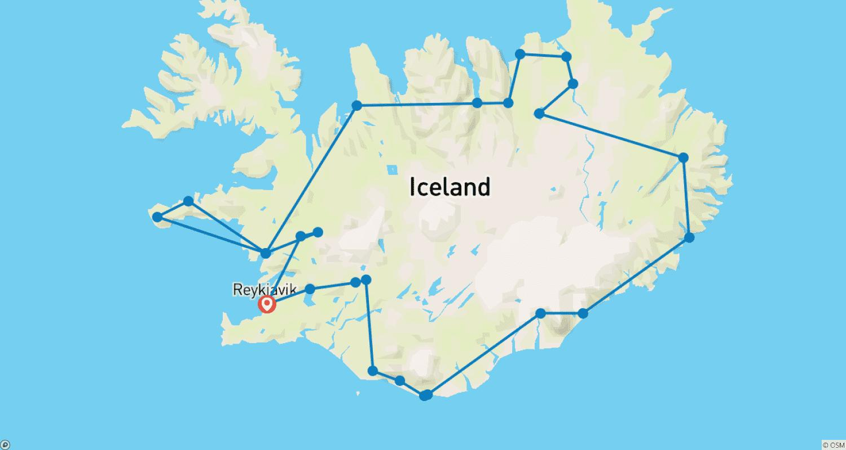

Tour ID: 221198  
Tour Name: 9 Day - Iceland Ring Road, Highlands and Volcano Adventure

Tour destinations: ['Reykjavik', 'Vik', 'Fjadrargljufur', 'Vatnajokull National Park', 'Eldgja', 'Landmannalaugar', 'Geysir', 'Gullfoss', 'Skogafoss', 'Skaftafell', 'Hofn', 'Jokulsarlon', 'Reynisfjara', 'Djupivogur', 'Egilsstadir', 'Myvatn', 'Hverfjall Volcano', 'Godafoss', 'Akureyri', 'Dalvik', 'Siglufjordur', 'Borgarnes', 'Grindavik']

Tour destinations images:

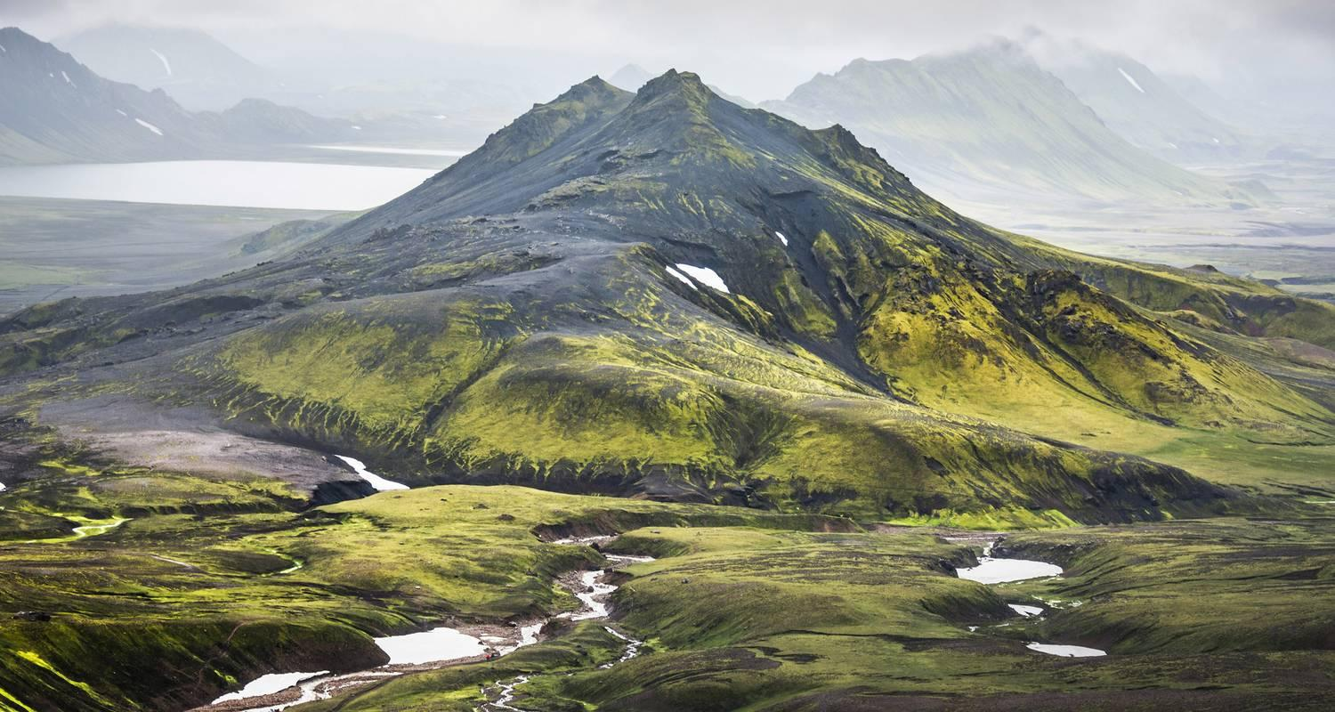

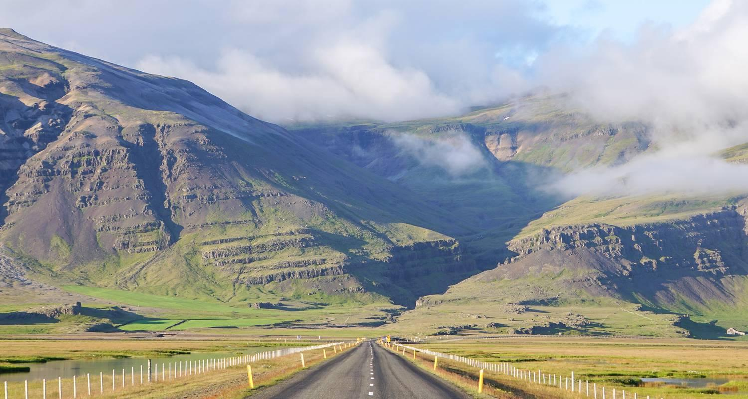

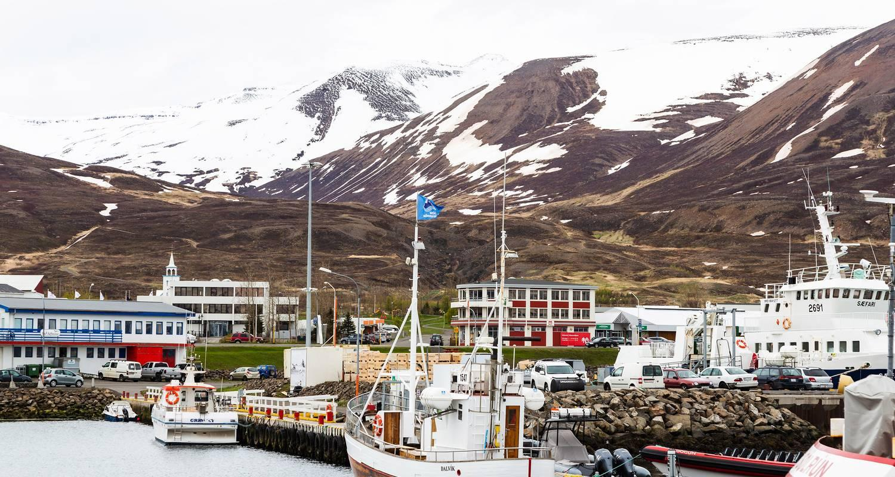

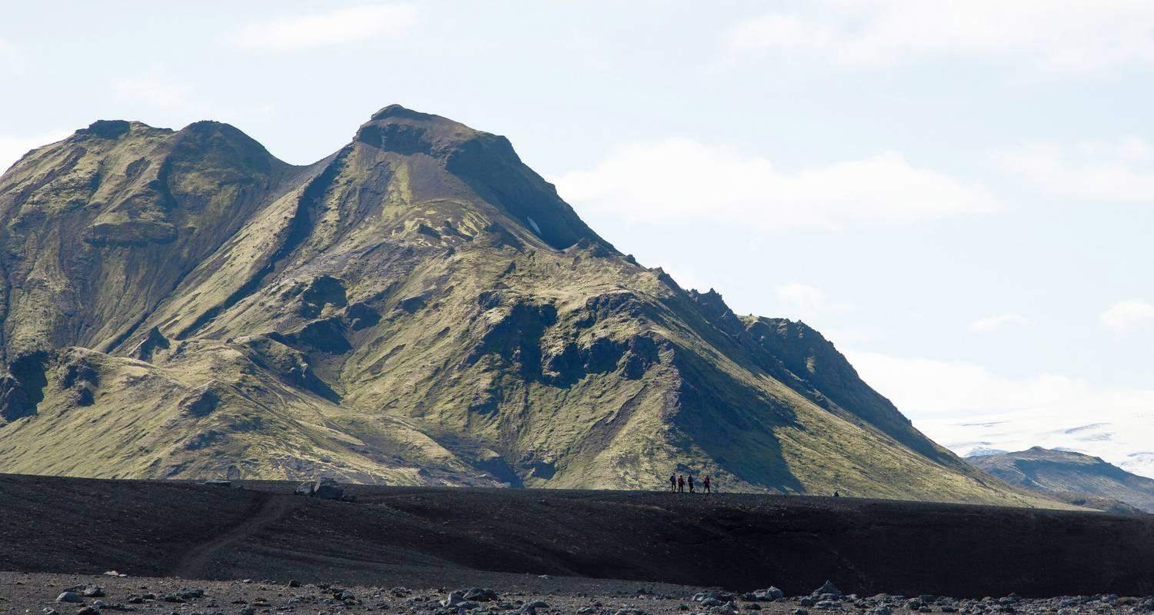

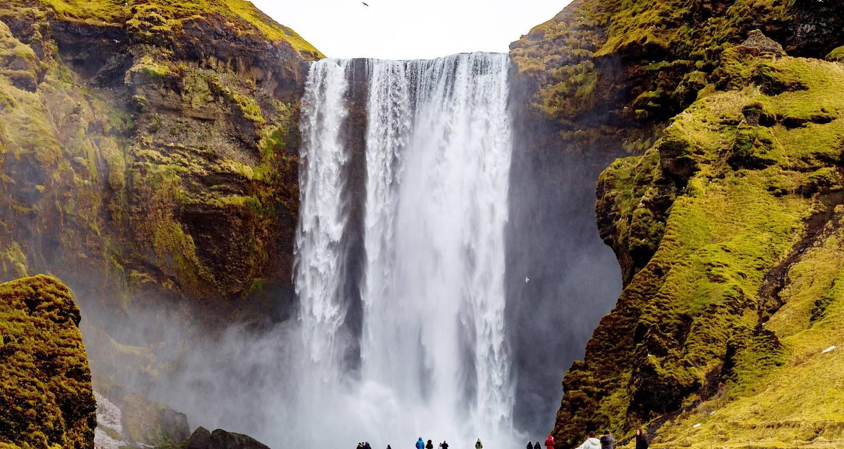

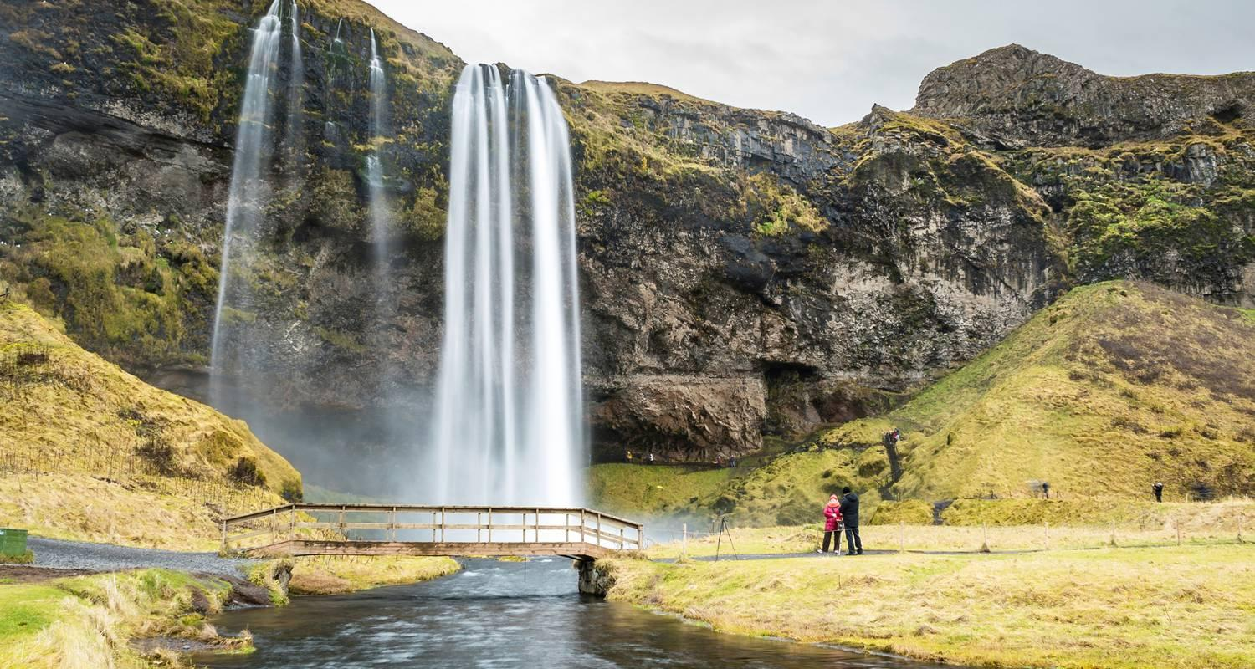

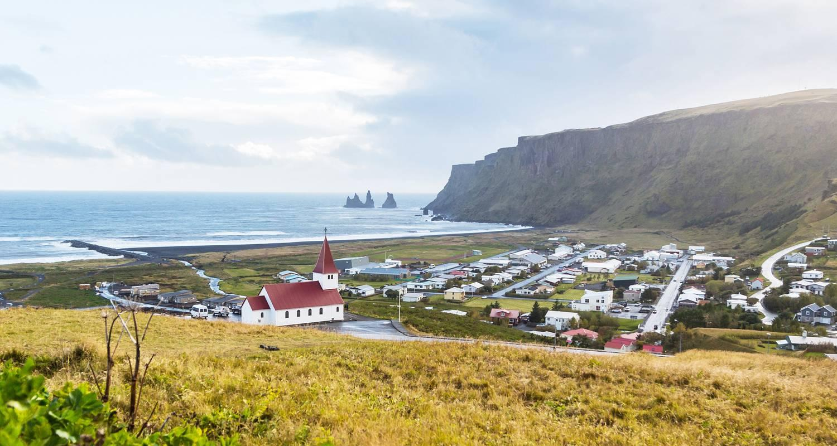

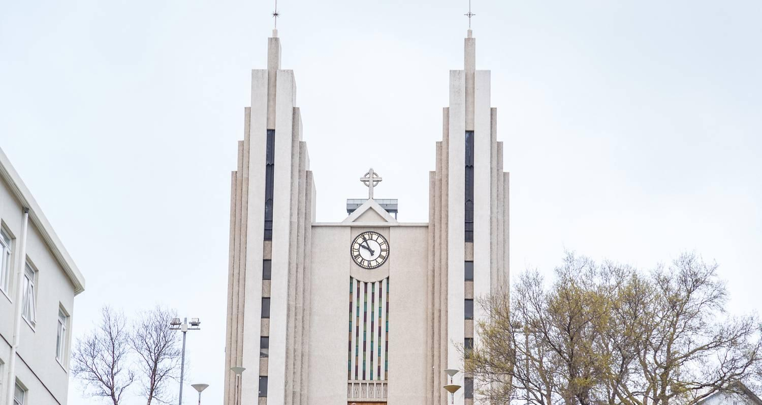

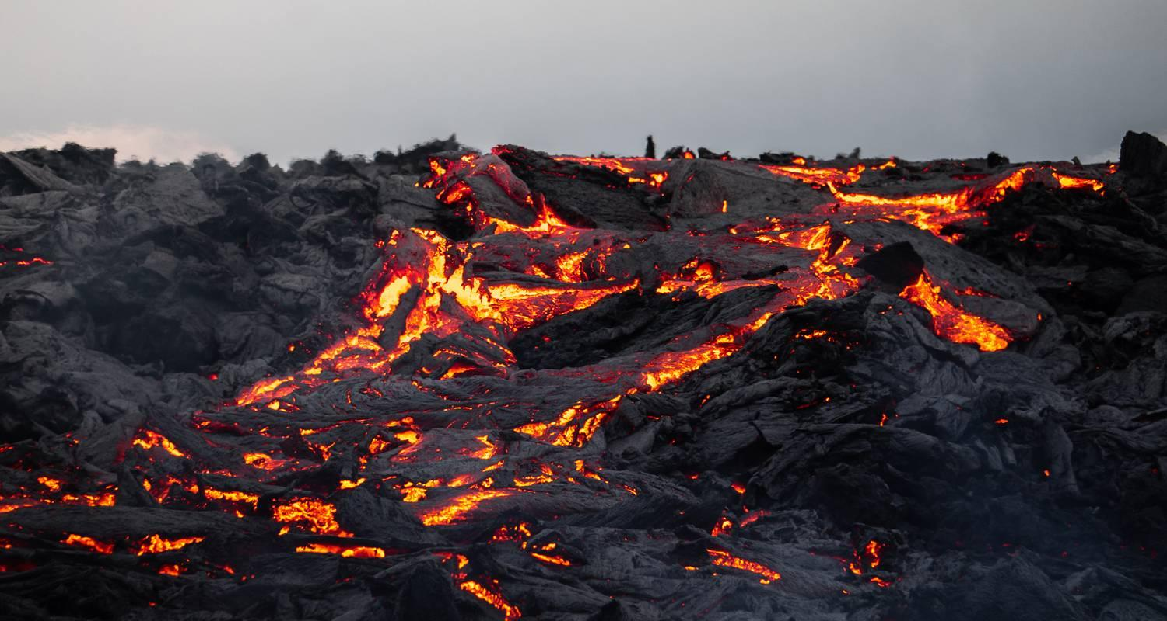

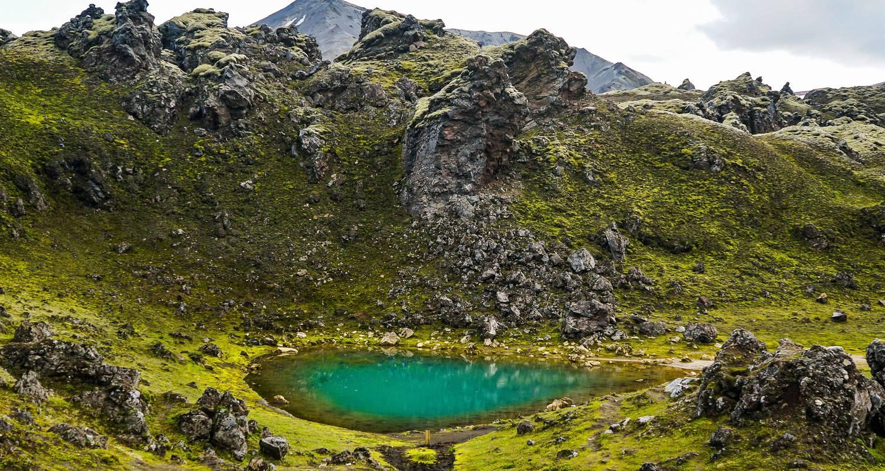

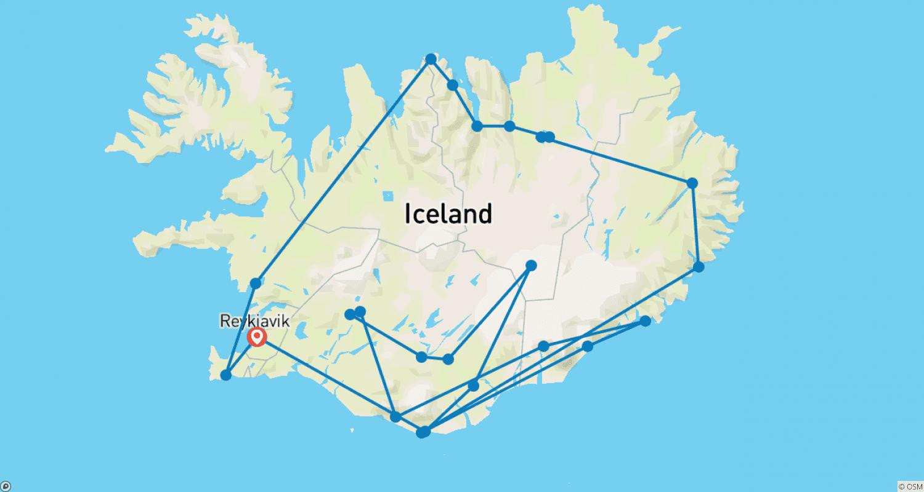

Tour ID: 221290  
Tour Name: 10 Days Complete Iceland | Ring-Road, Snæfellsnes Peninsula & Roundtrip airport transfer (Group Tour)

Tour destinations: ['Keflavik', 'Blue Lagoon', 'Thingvellir National Park', 'Gullfoss', 'Geysir', 'Seljaland', 'Skogafoss', 'Vik', 'Jokulsarlon', 'Egilsstadir', 'Myvatn', 'Akureyri', 'Hvitserkur', 'Reykjavik', 'Djupalonssandur', 'Borgarnes', 'Reykholt']

Tour destinations images:



